**Introduction To JAVA**

**Why Java Is :**

Java programs made such a big splash on the Web because they offered interactivity in a medium that was largely one way. The Web distributes almost all information in a passive manner. Someone using a browser asks for a page, looks it over, asks for another, looks it over, and so on. Lather, rinse, repeat.

A Java applet running on a Web page provides a much richer experience-both in terms of information and user interaction. Information can change in response to user input or be updated dynamically as a Web page is viewed. The applet, offered by JavaWorld magazine in conjunction with Quote.Com, updates a stock portfolio dynamically with quotes updated in real time.

Although Web-based programs are a strength of the language, Java is a general-purpose language that can be used to develop all kinds of programs.

A Java program is created as a text file with the file extension java. It is compiled into one or more files of bytecodes with the extension .class. Bytecodes are sets of instructions similar to the machine code instructions created when a computer program is compiled. The difference is that machine code must run on the computer system it was compiled for, and bytecodes can run on any computer system equipped to handle Java programs.

**Java Is Internationally Beloved :**

Although "internationally beloved" might be pushing it a bit, Java has quickly become a popular choice for computer programming-both on and off the Internet. A lot of the initial interest undoubtedly came from people who wanted to know whether Java lived up to the hype. In a short time, the language has become one of the biggest buzzwords of the Internet, spawning magazines, Web sites, training courses, conferences, and more than 120 books.

Even if Java was as underpublicized as Tonya Harding's singing career, the programming language has some advantages over other languages such as C++ and Visual Basic.

Java is just a small, simple, safe, object-oriented, interpreted or dynamically optimized, byte-coded, architecture-neutral, garbage-collected, multithreaded programming language with strongly typed exception handling mechanism for writing distributed, dynamically extensible programs. These adjectives can be tackled by dividing them into more manageable groups.

**Java Is Small and Simple**

When James Gosling retreated to his office to write the language that became Java, it was modeled after C and C++. The object-oriented approach, and most of Java's syntax, is adapted from C++. Programmers who are familiar with that language (or with C) will have a much easier time learning Java because of the common features.

However, Java has been described as "C++ minus" because of elements of C++ that were omitted. Gosling wanted to avoid the problems that the Green project had encountered when using C++ as it developed the Star7 prototype. The most complex parts of C++ were excluded from Java, such as pointers and memory management. These elements are complicated to use, and are thus easier to use incorrectly. Finding a pointer error in a large program is an experience not unlike searching for the one-armed man who framed you for murder. Memory management occurs automatically in Java-programmers do not have to write their own garbage-collection routines to free up memory.

Another design decision to make Java simpler is its elementary data types and objects. The language enforces very strict rules regarding variables-in almost all cases, you have to use variables as the data type they were declared to be, or use explicit casts to manipulate them. This arrangement permits mistakes in variable use to be caught when the program is compiled, rather than letting them creep into a running program where they're harder to find. As a result, programs behave in a more predictable manner.

Experienced programmers may have trouble adjusting to some of the changes and reductions from C++. However, Java's developers were trying to make the language easier to write, debug, and learn.

**Java Is Object Oriented**

Object-oriented programming (OOP) is a powerful way of organizing and developing software. The short-form description of OOP is that it organizes a program as a set of components called objects. These objects exist independently of each other, and they have rules for communicating with other objects and for telling those objects to do things. Think back to how Star7 devices were developed as a group of independent devices with methods for communicating with each other. Object-oriented programming is highly compatible with what the Green project was created to do and, by extension, for Java as well.

Java inherits its object-oriented concepts from C++ and other languages such as Smalltalk. The fact that a programming language is object oriented may not seem like a benefit to some. Object-oriented programming can be an intimidating subject to tackle, even if you have some experience programming with other languages. However, object-oriented programs are more adaptable for use in other projects, easier to understand, and more bugproof.

The language includes a set of class libraries that provide basic variable types, system input and output capabilities, and other functions. It also includes classes to support networking, Internet protocols, and graphical user interface functions. There's a lot of excitement in the programming community because Java provides a new opportunity to use object-oriented techniques on the jobs. Smalltalk, the language that pioneered object-oriented programming in the 1970s, is well-respected but has never been widely adopted as a software development choice. As a result, getting the go-ahead to develop a project using Smalltalk can be an uphill struggle. C++ is object oriented, but concerns about its use have already been described. Java is overcoming the hurdle in terms of usage, especially in regard to Internet programming and the development of distributed applications.

**Java Is Safe**

Another thing essential to Java's success is that it be safe. The original reason for Java to execute reliably was that people expect their waffle irons not to kill them or to exhibit any other unreliable behavior. This emphasis on security was well-suited for Java's adaptation to the World Wide Web.

A Java program that executes from a Web page is called an applet. All other Java programs are called applications. When an applet is encountered on a Web page (if the user's browser can handle Java), the browser downloads the applet along with the text and images on the page. The applet then runs on the user's computer. This act should raise a red flag-danger! danger!-because a lot of harmful things can occur when programs are executed: viruses, Trojan horses, the Microsoft Network, and so on.

Java provides security on several different levels. First, the language was designed to make it extremely difficult to execute damaging code. The elimination of pointers is a big step in this regard. Pointers are a powerful feature, as the programmers of C-like languages can attest, but pointers can be used to forge access to parts of a program where access is not allowed, and to access areas in memory that are supposed to be unalterable. By eliminating all pointers except for a limited form of references to objects, Java is a much more secure language.

Another level of security is the bytecode verifier. As described earlier, Java programs are compiled into sets of instructions called bytecodes. Before a Java program is run, a verifier checks each bytecode to make sure that nothing suspicious is going on.

In addition to these measures, Java has several safeguards that apply to applets. To prevent a program from committing random acts of violence against a user's disk drives, an applet cannot open, read, or write files on the user's system. Also, because Java applets can open new windows, these windows have a Java logo and text that identifies their identity. This prevents one of these pop-up windows from pretending to be something such as a user name and password dialog box. There is no system of security that is completely foolproof, and there were several instances in the first year after Java's release where security bugs were brought to Sun's attention by programmers such as David Hopwood. The following Web site describes some of these incidents and outlines the issues regarding safe Internet programming:

Because of the multiple levels of security, and the continued efforts to improve these measures, Java is generally regarded as a secure means to execute code over the World Wide Web.

**Java Is Platform Independent**

Platform independence is another way of saying that Java is architecture neutral. If both terms leave you saying "huh?", they basically mean that Java programs don't care what system they're running on.

Most computer software is developed for a specific operating system. Platform independence is the ability of the same program to work on different operating systems; Java is completely platform independent. Java's variable types have the same size across all Java development

platforms-so an integer is always the same size, no matter which system a Java program was written and compiled on. Also, as shown by the use of applets on the Web, a Java .class file of bytecode instructions can execute on any platform without alteration.

Sun Microsystems has been aggressive in making Java available on different systems. As JavaSoft President Alan Baratz says, "Anything that feels, smells, walks, or talks like it has a processor-we'd like the Java platform to live on it." There are Java interpreters that can run programs for Microsoft Windows 95 and NT, Apple Macintosh 7.5, SPARC Solaris 2.3 or higher, and Intel x86 Solaris; other systems have Java versions under development.

Java's declaration of platform independence is often trumpeted by Java advocates as a major accomplishment because it opens up a much larger audience for programs than has been readily available in the past. Although no major commercial releases of Java-based software have been introduced as of this writing (other than JavaSoft products such as HotJava and the Java WorkShop programming environment), several have been announced.

**Java Is That Other Stuff, Too**

One adjective that has been left out thus far is that Java is multithreaded. Threads represent a way for a computer program to do more than one task at the same time. Many operating systems are multitasking. Windows 95, for example, enables a person to write a book chapter with Word in one window while using Netscape Navigator to download every known picture of E! host Eleanor Mondale in the other. (Speaking hypothetically, of course.)

A multithreaded language extends this schizophrenic behavior to programs so that more than one set of instructions can be executed concurrently. Java provides the tools to write multithreaded programs and to make these programs reliable in execution.

Another thing that should be highlighted is Java's network-centric nature. Sun, the company that trademarked the phrase, "the network is the computer," has created a language that backs it up. Star7 was able to pass an object from one device to another using radio signals, and Java makes it possible to create applications that communicate across the Internet in the same way.

Its networkability may be the area in which Java truly separates itself from other languages that can be used for development. As language creator James Gosling has remarked, "The thing that distinguishes Java is its approach to distributed programming."

**JAVA INTRODUCTION**

Java is a general-purpose, object-oriented programming language. We can develop two types of Java programs:

* Stand-alone application
* Web applets

Stand-alone applications are programs written in Java to carry out certain tasks on a stand-alone local computer. In fact, Java can be used to develop programs for all kinds of applications, which earlier, were developed using languages like C and C++. As pointed out earlier, HotJava itself is a Java application program. Executing stand-alone Java program involves two steps:

1. Compiling source code into bytecode using javac compiler

2. Executing the bytecode program using java interpreter.

Applet are small Java developed for Internet applications. An applet located on a distant computer (Server) can be downloaded via Internet and executed on a local computer (Client) using a Java-capable browser .We can develop applets for doing everything from simple animated graphics to complex games and utilities.

**Applet Type**

**Application Type**

**Output**

**Output**

**Java Compiler**

**JAVA PROGRAM STRUCTURE**

|  |
| --- |
| Documentation  Section Suggested |
| Package Statement Optional |
| Import Statement Optional |
| Interface Satatement Optional |
| Class Definations Optional |
| Main Method Class  {  Main Method Essential    Defination  } |

**Genral Structure of a java program**

**Documentation Section**

The documentation section comprises a set of comment lines giving the nameof the program, the author and details, which the programmer would like referto at a later stage. Comments must explain why and what of classes and how of algorithms. This would greatly help in maintaining the program .In addition to the two styles of comments discussed earlier, Java also uses a third style of comments /**......*/ known as documentation comments. This form of comments is used for generating documentation automatically.

**Package Statement:** The first statements allowed in a Java file is a package statements. This statements declares a package name and informs the compiler that the classes defined here belong to this package.

Example:

package student ;

The package statement is optional.

**Import Statements**The next thing after a package statement (but before any class definition s) may be a number of import statements. This is similar to the #include statements in C.

Example: import student test;

This statement instructs the interpreter to load the test class contained in the package student. Using import statements, we can have access to classes that are part of other named packages.

**Interface Statements**

An interface is like a class but includes a group of method declarations. This is also an optional section and is used only when we wish to implement the multiple inheritance features in the program. Interface is a new concept in Java.

**Class Definitions**

A Java program may contain multiple class definitions. Classes are the primary and essential elements of a Java program. These classes are used to map objects of real-word problems. The number of classes used depends on the complexity of the problem.

**Main Method Class**

Since every Java stand-alone program requires a main method as its starting points, this class is the essential part of a Java program. A simple Java program may contain only this part. The main method creates objects of various classes and establishes communications between them.

**JAVA FEATRES**

The inventors of Java wanted to design a language which could offer solutions to some of the problems encountered in modern programming. They wanted the language to be not only reliable, portable and distributed but also simple, compact and interactive. Sun Microsystems officially describes Java with the following attributes:

* Compiled and Interpreted
* Platform-Independent and Portable
* Object-Oriented
* Robust and secure
* Distributed
* Familiar, Simple and Small
* Multithreaded and Interactive
* High Performance
* Dynamic and Extensible.

Although the above appears to be a list of buzzwords, they aptly describe the full potential of the language. These features have made Java the first application language of the World Wide Web. Java will also become the premier language for purpose stand-alone applications.

**Compiled and Interpreted:** Usually a computer language is either compiled or interpreted. Java combines both these approaches thus making Java a two-stage system. First, Java compiler translates source code into what is known as bytecode instructions. Bytecodes are not machine instructions and therefore, in the second stage, Java interpreter generates machine code that can be directly executed by the machine that running the Java program. We can thus say that Java is both a compiled and an interpreted language.

**Platform-Independent and Portable:** The most significant contribution of Java over language is its portability. Java programs can be easily moved from one computer system to another, anywhere and anytime. Changes and upgrades in operating systems, processors and system resources will not force any changes in Java programs. This is the reason why Java has become a popular language for programming on Internet which interconnects different kinds of systems worldwide. We can download a Java applet from a remote computer onto our local system via Internet and execute it locally. This makes the Internet an extension of the user's basic system providing practically unlimited number of accessible applets windows and applications.Java ensures portability in two ways. First, Java compiler generates bytecode instructions that can be implemented on any machine. Secondly, the size of the primitive data types are machine-independent.

**Object-Oriented:** Java is a true object-oriented language. Almost everything in Java is an object. All program code and data reside within objects and classes. Java comes with an extensive set of classes, arranged in packages that we can use in our program by inheritance. The object model in Java is simple and easy to extend.

**Robust and Secure:** Java is a robust language. It provides many safeguards to ensure reliable code. It has strict compile time and run time checking for data types. It is designed as a garbage-collected language relieving the programmers virtually all memory management problems. Java also incorporates the concept of exception handling which captures series errors and eliminates any risk of crashing the system.

Security becomes an important issue for a language that is used for programming on Internet. Threat of viruses and abuse of resources is everywhere. Java systems not only verity all memory access but also ensure that no viruses are communicated with an applet. The absence of pointers in java ensures that programs cannot gain access to memory locations without proper authorization.

**Distributed :**Java is designed as a distributed language for creating applications on networks. It has the ability to share both data and programs. Java application can open and access remote objects on Internet as easily as they can do in a local system. This enables multiple programmers at multiple remote locations to collaborate and work together on a single project.

**Simple, Small and Familiar:** Java is a small and simple language. Many features of C and C++ that are either redundant or sources of unreliable code are not part of Java. For example, Java does not use pointers, preprocessor header files, goto statement and many others. It also eliminates operator overloading and multiple inheritance. For major detailed comparison of Java with C and C++.

**Multithreaded and Interactive:** Multithreaded means handling multiple tasks simultaneously. Java supports multithreaded programs. This means that we need not wait for the application to finish one task before beginning another. For example, we can listen to an audio clip while a page and at the same time download an applet from a distant computer. This feature greatly improves the interactive performance of graphical applications.The Java runtime comes with tools that support multiprocessor synchronization and construct smoothly running interactive systems.

**High Performance:** Java performances is impressive for an interpreted language, mainly due to the use of intermediate bytecode. According to Sun, Java speed is comparable to the native C/C++. Java architecture is also designed to reduce overheads during runtime. Further, the incorporation of multithreading enhance the overall execution speed of Java programs.

**Dynamic and Extensible:** Java is a dynamic language. Java is capable of dynamically linking in new class libraries, methods, and objects. Java can determine the type of class through a query, making it possible to either dynamically link or abort the program, depending on the response.Java programs support functions written in other language such as C and C++. These functions are known as native methods. This facility enables the programmers to use the efficient functions available in these language. Native methods are linked dynamically at runtime.

**More Features of the Java Language:** The previous lesson, Objects and Classes in Java, described features of the Java language that every Java programmer needs to know to use objects and write classes in Java. This lesson builds on that, discussing more features of the Java language that help you to organize and design your code.

**Managing Inheritance:** This section tells you what you need to know to manage inheritance up and down from your classes. First, it describes generally what a subclass gets from its ancestors and specifically what every class gets from the object class. Second, it discusses how to control whether your class can be subclassed and whether its subclasses can override its methods.

**Creating Interfaces:** You saw an example of implementing an interface in the previous chapter. You can read more about interfaces--what they are for, why you might need to write an interface, and all about how to write one-in this section.

**Implementing Nested Classes:** You learned how to use inner classes to implement an adapter in Using an Inner Class to Implement an Adapter in the previous lesson. Inner Classes are one type of nested classes that you will learn about here.

**Creating and Using Packages:** This section describes how to bundle your classes into packages and how to use classes that are in package.

**JAVA SUPPORT SYSTEMS:** It is clear from the discussion we had up to now that the operation of Java and Java-enabled browsers on the Internet requires a variety of support systems.

|  |
| --- |
| **Support System Description** |
| Internet Connection Local computer should be connected to the  Internet.  Web Server A program that accepts requests forInformation and Sends the required documents.  Web Browser A program that provides access to WWW and  runs Java applets.  HTML A language for creating hypertext for the web.  APPLET Tag For placing java applets in HTML document.  Java Code Java code is used for defining Java applets.  Bytecode Compiled Java code that is referred to in the Applet Tag and transferred to the user computer. |
|  |

**SWING:** Many new features have been added to Swing. The new **spinner** component is a single line input field that allows the user to select a number or a value by cycling through a sequence of values using a tiny pair of up/down arrow buttons. The new **formatted text field** component allows formatting of dates, numbers, and strings, such as a text field that accepts only decimal money values. The **Windows look and feel** implementation is updated to track features available in the 2000/98 versions. A new **drag and drop architecture** provides seamless drag and drop support between components as well as an easy way to implement drag and drop in your customized Swing components - writing a couple of methods which describe the particulars of your data model is all that is required. Swing's progress bar component has been enhanced to support an indeterminate state; rather than showing the degree of completeness, the **indeterminate progress bar** uses constant animation to show that a time-consuming operation is occurring. Due to great customer demand, the tabbed pane component has been enhanced to support **scrollable tabs**. With this feature enabled, if all the tabs will not fit within a single tab run, the tabbed pane component will display a single, scrollable run of tabs, instead of wrapping the tabs onto multiple runs. The **popup and** **popup factory** classes, which were previously package private, have been exposed and made public so that programmers may customize or create their own popups. The new **focus architecture** is fully integrated into Swing.

**Swing Features and Concepts:** This lesson introduces Swing's features and explains all the concepts you need to be able to use Swing components effectively. At the end of this lesson we dissect a Swing program, as a means of reviewing everything you've learned.

* **Swing Components and the Containment Hierarchy**

Swing provides many standard GUI components such as buttons, lists, menus, and text areas, which you combine to create your program's GUI. It also includes containers such as windows and tool bars.

* **Layout Management**

Containers use layout managers to determine the size and position of the components they contain. Borders affect the layout of Swing GUIS by making Swing components larger. You can also use invisible components to affect layout.

* **Event Handling**

Event handling is how programs respond to external events, such as the user pressing a mouse button. Swing programs perform all their painting and event handling in the event-dispatching thread.

* **Painting**

the component on-screen. Although it's easy to customize a component's painting, most programs don't do anything more complicated than customizing a component's border.

* **Threads and Swing**

if you do something to a visible component that might depend on or affect its state, then you need to do it from the event-dispatching thread. This isn't an issue for many simple programs, which generally refer to components only in event-handling code. However, other programs need to use the invokeLater method to execute component-related calls in the event-dispatching thread.

* **More Swing Features and Concepts**

Swing offers many features, many of which rely on support provided by the JComponent class. Some of the interesting features this lesson hasn't discussed yet include support for icons, actions, Pluggable Look & Feel technology, assistive technologies, and separate models.

* **The Anatomy of a Swing-Based Program**

A sample Swing application named Converter shows how Swing programs work and how the code hangs together.

**SWING COMPONENTS CLASS**

* **JApplet:** Fundamental to the JApplet class, Which extends Applet. Applets that use Swing must be subclasses of JApplet JApplet is rich with functionality that is not found in Applet. For example, JApplet supports various "panes," such as the content pane, the glass pane, and the root pane. For the examples in this chapter,we will not be using most of JApplet's enhanced features. However, one difference between Applet and JApplet is important to this discussion, because it is used by the sample applets the this chapter. When adding a component to an instance of JApplet, do not invoke the add() method of the applet. Instead, call add() for content pane of the JApplet object. The content pane can be obtained via the method shown here:

Container getContentPane() The add() method of Container can be used to add a component yo a content pane.Its form is shown here:

Void add(comp)

* **JLabel:** Swing labels are instances of the JLabel class, which extends Jcomponents .Itcan display text and/or an icon. Some of its constructors are shown here:

JLabel(Icon i

Label(String s)

JLabel(Strings, Icon I, int align)

Here,s and I are the text and icon used for the label.The align argument is either LEFT,RIGHT, CENTER, LEADING ,or TRAILING.

* **JTextField:** The Swing text field is encapsulated by the JtextComponent class, which extends JComponents. It provides functionality that is common to Swing text components. One of its subclasses is JTextField, which allows you to edit one line of text.Some of its constructor are shown here:

JC JTextField()

Jom JTextField(int cols)

JTextField(String s, int cols)

JtextField(String s)

Here, s is the string to be presented and cols is the number of columns in the text field.

* **JButton :** The JButton class provides the functionality of a push button. JButton allows an icon, a string, or both to be associated with the push button. Some of its constructor are shown here:

JButton(Icon i)

JButton(Strings)

JButton(String s, Icon i)

Here, s and I are the string and icon used for the button.

* **JComboBox**: Swing provides a combo box(a combination of text field and a drop down list) through the Jcombobox class, which extends Jcomponent. A combo box normally displays one entry. However, it can also display a drop-own list that allows a user to select a different entry. You can also type your selection into the text field. Two of JcomboBox'constructors are shown here:

**JComboBox()** JcomboBox(Vector v)Here, v is a vector that initializes the combo box.

Items are added to the list of choices via the addItem() method, whose signature is shown here:

Void addItem(Object obj)

Here, obj is the object to be added to the combo box.

* **JTabbedPanes** :A tabbed pane is a component that appears as a group of folders in a file cabinet. Each folder has a title. When a user selects a folder, its contents become visible. Only one of the folders may be selected at a time. Tabbed panes are encapsulated by the JTabbedPane class,whch extends JComponent. We will use its default constructor. Tabs are defined via the following method:

Void addTab(String str, Component comp)

Here, str is the title for the tab, and comp is the component that should be added to the tab. Typically, a Jpanel or a subclass of it is added.

The general procedure to use a tabbed pane in an applet is outlined here:

1. Create a JtabbedPane object.

2. Call addTab() to add a tab to the pane.(The arguments to this methoddefine the title of the tab and the component it contains.)

3. Repeat step2 for each tab.

4. Add the tabbed pane to the content pane of the applet.This property makes it possible to associate a tooltip with a tab, after the tab has been added.

* **Jtabel:** As a result of JTable changes, code written for v 1.2 or for JFC/Swing 1.1 might have the following problems when run in v 1.3: Since the Table Column get Header Renderer method now returns nullby default, you can't use that method to get the default header renderer. Instead, change your code to use the JTableHeader get Default Renderer method. See How to Use Tables in The Java Tutorial for an example.

Because JTable's default text editor is now smarter about data types, it now gives setValueAt objects of the appropriate type, instead of always specifying strings. For example, if setValueAt is invoked for an Integer cell, then the value is specified as an Integer instead of a String. If you implemented a table model, then you might have to change its setValueAt method to take the new data type into account. If you implemented a class used as a data type for cells, make sure that your class has a constructor that takes a single String argument.

**Column and Row Layout Improvements:** We made the following changes:

**Improved performance in tables with large numbers of columns:**

Moving the header renderers from the columns themselves to the table header represents the most significant change to performance and footprint by sharing similar header renderers on a per-table basis.

**Dynamic changing of individual row height:** The rendering machinery in the JTable has been substantially overhauled in this release to enable this much sought after feature in the JTable. Simplified creation of non-standard editor components The AbstractCellEditor class has been included in response to continued feedback on the difficulty of creating non-standard editor components.

**Better handling of inter-cell spacing:** Previously JTable did not correctly implement its specification for inter-cell spacing. Changes in the inter-cell spacing affected a number of other properties including the overall height of the table. In v 1.3, the inter-cell spacing has only one effect: to provide an inset for the cells, where the inset is the amount that renderers and editors are shrunk to accommodate the spacing between the cells.

For more information, see the API documentation for the following methods and fields. Note that "obsolete" means that you should avoid using the obsolete API, but that using the API isn't dangerous enough to warrant a compile-time warning. "Deprecated" API, on the other and, is not only obsolete but also results in a compile-time warning.

* **Jframe:**

**Add EXIT ON CLOSE defaultCloseOperation Constant**

JFrame provides the setDefaultCloseOperation method which can be used to configure the default action when a JFrame is closed. For single framed applications it often the case that closing the frame will exit the application. Previously, developers had to add a WindowListener and do this themselves. To make this common case easier for developers to accomplish, a constant has been added to JFrame that specifies when the frame closes the application should exit: See: public static final int EXIT_ON_CLOSE .

# Introduction to MySQL

# Introduction MySQL Java: MySQL is a fast, easy-to-use RDBMS being used for many small and big businesses. MySQL is developed, marketed and supported by MySQL AB, which is a Swedish company. MySQL is becoming so popular because of many good reasons :

* MySQL is released under an open-source license. So you have nothing to pay to use it.
* MySQL is a very powerful program in its own right. It handles a large subset of the functionality of the most expensive and powerful database packages.
* MySQL uses a standard form of the well-known SQL data language.
* MySQL works on many operating systems and with many languages including PHP, PERL, C, C++, JAVA, etc.
* MySQL works very quickly and works well even with large data sets.
* MySQL is very friendly to PHP, the most appreciated language for web development.
* MySQL supports large databases, up to 50 million rows or more in a table. The default file size limit for a table is 4GB, but you can increase this (if your operating system can handle it) to a theoretical limit of 8 million terabytes (TB).
* MySQL is customizable. The open-source GPL license allows programmers to modify the MySQL software to fit their own specific environments.

## JDBC: JDBCis an API for the Java programming language that defines how a client may access a database. It provides methods for querying and updating data in a database. JDBC is oriented towards relational databases. From a technical point of view, the API is as a set of classes in the java.sql package. To use JDBC with a particular database, we need a JDBC driver for that database.

JDBC is a cornerstone for database programming in Java. Today, it is considered to be very low-level and prone to errors. Solutions such as MyBatis or JdbcTemplate were created to ease the burden of JDBC programming. However, under the hood, these solutions still use JDBC. JDBC is part of the Java Standard Edition platform.

JDBC manages these three main programming activities:

* connecting to a database;
* sending queries and update statements to the database;
* retrieving and processing the results received from the database in answer to the query.

## MySQL Connector/J: To connect to MySQL in Java, MySQL provides MySQL Connector/J, a driver that implements the JDBC API. MySQL Connector/J is a JDBC Type 4 driver. The Type 4 designation means that the driver is a pure Java implementation of the MySQL protocol and does not rely on the MySQL client libraries. In this tutorial, we use MySQL Connector/J 5.1.41, which is a maintenance release of the 5.1 production branch.

## Connection string : A database connection is defined with a connection string. It contains information such as database type, database name, server name, and port number. It also may contain additional key/value pairs for configuration. Each database has its own connection string format. The following is a syntax of a MySQL connection string:

jdbc:mysql://[host1][:port1][,[host2][:port2]]...[/[database]]

[?propertyName1=propertyValue1[&propertyName2=propertyValue2]...]

It is possible to specify multiple hosts for a server failover setup. The items in square brackets are optional. If no host is specified, the host name defaults to localhost. If the port for a host is not specified, it defaults to 3306, the default port number for MySQL servers.

jdbc:mysql://localhost:3306/testdb?useSSL=false

This is an example of a MySQL connection string. The jdbc:mysql:// is known as a sub-protocol and is constant for MySQL. We connect to the localhost on MySQL standard port 3306. The database name is testdb. The additional key/value pairs follow the question mark character (?). The useSSL=false tells MySQL that there will be no secure connection.

## About MySQL database: MySQL is a leading open source database management system. It is a multiuser, multithreaded database management system. MySQL is especially popular on the web. It is one part of the very popular LAMP platform consisting of Linux, Apache, MySQL, and PHP. Currently MySQL is owned by Oracle. MySQL database is available on most important OS platforms. It runs on BSD Unix, Linux, Windows, or Mac OS. Wikipedia and YouTube use MySQL. These sites manage millions of queries each day. MySQL comes in two versions: MySQL server system and MySQL embedded system.

## Setting up MySQL: In this section, we are going to install MySQL server, create a testdb database, and a test user.

$ sudo apt-get install mysql-server

This command installs the MySQL server and various other packages. While installing the package, we are prompted to enter a password for the MySQL root account. Next, we are going to create a new database user and a new database. We use the mysql client.

$ sudo service mysql status

mysql start/running, process 5129

We check if the MySQL server is running. If not, we need to start the server. On Ubuntu Linux, this can be done with the sudo service mysql start command.

$ mysql -u root -p

Enter password:

Welcome to the MySQL monitor. Commands end with ; or \g. Your MySQL connection id is 43Server version: 5.7.21-0ubuntu0.16.04.1 (Ubuntu) Copyright (c) 2000, 2018, Oracle and/or its affiliates. All rights reserved.Oracle is a registered trademark of Oracle Corporation and/or its affiliates. Other names may be trademarks of their respective owners. Type 'help;' or '\h' for help. Type '\c' to clear the current input statement.

mysql> SHOW DATABASES;

+--------------------+

| Database |

+--------------------+

| information_schema |

| mysql |

+--------------------+

2 rows in set (0.00 sec)

We use the mysql monitor client application to connect to the server. We connect to the database using the root account. We show all available databases with the SHOW DATABASES statement.

mysql> CREATE DATABASE testdb;

Query OK, 1 row affected (0.02 sec)

We create a new testdb database. We will use this database throughout the tutorial.

mysql> CREATE USER 'testuser'@'localhost' IDENTIFIED BY 'test623';

Query OK, 0 rows affected (0.00 sec)

mysql> USE testdb;

Database changed

mysql> GRANT ALL ON testdb.* TO 'testuser'@'localhost';

Query OK, 0 rows affected (0.00 sec)

mysql> quit;

Bye

We create a new database user. We grant all privileges to this user for all tables of the testdb database.

**Java MySQL version:** If the following program runs OK, then we have everything installed OK. We check the version of the MySQL server.

**JdbcMySQLVersion.java**

package com.zetcode;

import java.sql.Connection;

import java.sql.DriverManager;

import java.sql.ResultSet;

import java.sql.SQLException;

import java.sql.Statement;

import java.util.logging.Level;

import java.util.logging.Logger;

public class JdbcMySQLVersion {

public static void main(String[] args) {

String url = "jdbc:mysql://localhost:3306/testdb?useSSL=false";

String user = "testuser";

String password = "test623";

String query = "SELECT VERSION()";

try (Connection con = DriverManager.getConnection(url, user, password);

Statement st = con.createStatement();

ResultSet rs = st.executeQuery(query)) {

if (rs.next()) {

System.out.println(rs.getString(1));

}

} catch (SQLException ex) {

Logger lgr = Logger.getLogger(JdbcMySQLVersion.class.getName());

lgr.log(Level.SEVERE, ex.getMessage(), ex);

}

}

}

We connect to the database and get some info about the MySQL server.

String url = "jdbc:mysql://localhost:3306/testdb?useSSL=false";

This is the connection URL for the MySQL database. Each driver has a different syntax for the URL. In our case, we provide a host, a port, and a database name.

try (Connection con = DriverManager.getConnection(url, user, password);

Statement st = con.createStatement();

ResultSet rs = st.executeQuery(query)) {

We establish a connection to the database, using the connection URL, user name, and password. The connection is established with the getConnection() method.

The createStatement() method of the connection object creates a Statement object for sending SQL statements to the database.

The executeQuery() method of the connection object executes the given SQL statement, which returns a single ResultSet object. The ResultSet is a table of data returned by a specific SQL statement.

The try-with-resources syntax ensures that the resources are cleaned up in the end.

if (result.next()) {

System.out.println(result.getString(1));

}

A ResultSet object maintains a cursor pointing to its current row of data. Initially the cursor is positioned before the first row. The next() method moves the cursor to the next row. If there are no rows left, the method returns false. The getString() method retrieves the value of a specified column. The first column has index 1.

} catch (SQLException ex) {

Logger lgr = Logger.getLogger(JdbcMySQLVersion.class.getName());

lgr.log(Level.SEVERE, ex.getMessage(), ex);

}

In case of an exception, we log the error message. For this console example, the message is displayed in the terminal.

**Introduction to Electricity Billing System**

**Introduction of the Project Electricity Billing System:** The "Electricity Billing System" has been developed to override the problems prevailing in the practicing manual system. This software is supported to eliminate and in some cases reduce the hardships

faced by this existing system. Moreover this system is designed for the particular need of

the company to carry out operations in a smooth and effective manner.

The application is reduced as much as possible to avoid errors while entering the data. It also provides error message while entering invalid data. No formal knowledge is needed for the user to use this system. Thus by this all it proves it is user-friendly. Electricity Billing System , as described above, can lead to error free, secure, reliable and Fast management system. It can assist the user to concentrate on their other activities rather to concentrate on the record keeping. Thus it will help organization in better utilization of resources.

Every organization, whether big or small, has challenges to overcome and managing The information of Bill, Customer, Electricity, Bill Receipt, Payment. Every Electricity Billing System has different Customer needs, therefore we design exclusive employee management systems that are adapted to your managerial requirements. This is designed to assist in strategic planning, and will help you ensure that your organization is equipped with the right level of information and details for your future goals.

Also, for those busy executive who are always on the go, our systems come with remote access features, which will all you to manage your workforce anytime, at all times. These systems will ultimately allow you to better manage resources.

**Scope of the project Electricity Billing System:** It may help collecting perfect management in details. In a very short time, the collection will be obvious, simple and sensible. It will help a person to know the management of passed year perfectly and vividly. It also helps in current all works relative to Electricity Billing System. It will be also reduced the cost of collecting the management & collection procedure will go on smoothly.

Our project aims at Business process automation, i.e. we have tried to computerize various processes of Electricity Billing System.

• In computer system the person has to fill the various forms & number of copies of the forms can be easily generated at a time.

• In computer system, it is not necessary to create the manifest but we can directly print it, which saves our time.

• To assist the staff in capturing the effort spent on their respective working areas.

• To utilize resources in an efficient manner by increasing their productivity through automation.

• The system generates types of information that can be used for various purposes.

• It satisfy the user requirement

• Be easy to understand by the user and operator

• Be easy to operate

• Have a good user interface

• Be expandable

• Delivered on schedule within the budget

**Reports of Electricity Billing System:**

• It generates the report on Customer, Bill, Bill Receipt

• Provide filter reports on Connection, Electricity, Payment

• You can easily export PDF for the Customer, Bill Receipt, Electricity

• Application also provides excel export for Bill, Connection, Payment

• You can also export the report into csv format for Customer, Bill, Payment

**Modules of Electricity Billing System:**

• Customer Management Module: Used for managing the Customer details.

• Payment Module : Used for managing the details of Payment

• Bill Receipt Module : Used for managing the details of Bill Receipt

• Bill Management Module: Used for managing the information and details of the Bill.

• Connection Module : Used for managing the Connection details

• Electricity Module : Used for managing the Electricity information

• Login Module: Used for managing the login details

• Users Module : Used for managing the users of the system

**Input Data and Validation of Project on Electricity Billing System:**

• All the fields such as Customer, Connection, Payment are validated and does not take invalid values

• Each form for Customer, Bill, Bill Receipt can not accept blank value fields

• Avoiding errors in data

• Controlling amount of input

• Integration of all the modules/forms in the system.

• Preparation of the test cases.

• Preparation of the possible test data with all the validation checks.

• Actual testing done manually.

• Recording of all the reproduced errors.

• Modifications done for the errors found during testing.

• Prepared the test result scripts after rectification of the errors.

• Functionality of the entire module/forms.

• Validations for user input.

• Checking of the Coding standards to be maintained during coding.

• Testing the module with all the possible test data.

• Testing of the functionality involving all type of calculations etc.

• Commenting standard in the source files.

**The software quality plan we will use the following SQA Strategy:**

• In the first step, we will select the test factors and rank them. The selected test factors such as reliability, maintainability, portability or etc, will be placed in the matrix according to their ranks.

• The second step is for identifying the phases of the development process. The phase should be recorded in the matrix.

• The third step is that identifying the business risks of the software deliverables. The risks will be ranked into three ranks such as high, medium and low.

**Features of the project Electricity Billing System:**

• Product and Component based

• Creating & Changing Issues at ease

• Query Issue List to any depth

• Reporting & Charting in more comprehensive way

• User Accounts to control the access and maintain security

• Simple Status & Resolutions

• Multi-level Priorities & Severities.

• Targets & Milestones for guiding the programmers

• Attachments & Additional Comments for more information

• Robust database back-end

• Various level of reports available with a lot of filter criteria’s

• It contain better storage capacity.

• Accuracy in work.

• Easy & fast retrieval of information.

• Well designed reports.

• Decrease the load of the person involve in existing manual system.

• Access of any information individually.

• Work becomes very speedy.

• Easy to update information .

**Software Requirement Specification :**The Software Requirements Specification is produced at the culmination of the analysis task. The function and performance allocated to software as part of system engineering are refined by establishing a complete information description, a detailed functional and behavioral description, an indication of performance requirements and design constraints, appropriate validation criteria, and other data pertinent to requirements.

**The proposed system has the following requirements:**

• System needs store information about new entry of Customer.

• System needs to help the internal staff to keep information of Bill and find them as per various queries.

• System need to maintain quantity record.

• System need to keep the record of Connection.

• System need to update and delete the record.

• System also needs a search area.

• It also needs a security system to prevent data.

**Identification of need:** The old manual system was suffering from a series of drawbacks. Since whole of the system was to be maintained with hands the process of keeping, maintaining and retrieving the information was very tedious and lengthy. The records were never used to be in a systematic order. there used to be lots of difficulties in associating any particular transaction with a particular context. If any information was to be found it was required to go through the different registers, documents there would never exist anything like report generation. There would always be unnecessary consumption of time while entering records and retrieving records. One more problem was that it was very difficult to find errors while entering the records. Once the records were entered it was very difficult to update these records.

The reason behind it is that there is lot of information to be maintained and have to be kept in mind while running the business .For this reason we have provided features Present system is partially automated (computerized), actually existing system is quite laborious as one has to enter same information at three different places.

**Following points should be well considered:**

• Documents and reports that must be provided by the new system: there can also be few reports, which can help management in decision-making and cost controlling, but since these reports do not get required attention, such kind of reports and information were also identified and given required attention.

• Details of the information needed for each document and report.

• The required frequency and distribution for each document.

• Probable sources of information for each document and report.

• With the implementation of computerized system, the task of keeping records in an organized manner will be solved. The greatest of all is the retrieval of information, which will be at the click of the mouse. So the proposed system helps in saving the time in different operations and making information flow easy giving valuable reports.

**Preliminary Product Description:** The first step in the system development life cycle is the preliminary investigation to determine the feasibility of the system. The purpose of the preliminary investigation is to evaluate project requests. It is not a design study nor does it include the collection of details to describe the business system in all respect. Rather, it is the collecting of information that helps committee members to evaluate the merits of the project request and make an informed judgment about the feasibility of the proposed project.

**Analysts working on the preliminary investigation should accomplish the following objectives**:

• Clarify and understand the project request

• Determine the size of the project.

• Assess costs and benefits of alternative approaches.

• Determine the technical and operational feasibility of alternative approaches.

• Report the findings to management, with recommendations outlining the acceptance or rejection of the proposal.

• Benefit to Organization The organization will obviously be able to gain benefits such as savings in operating cost, reduction in paperwork, better utilization of human resources and more presentable image increasing goodwill.

• The Initial Cost The initial cost of setting up the system will include the cost of hardware software (OS, add-on software, utilities) & labour (setup & maintenance). The same has to bear.

* **Running Cost** Besides, the initial cost the long term cost will include the running cost for the system including the AMC, stationary charges, cost for human resources, cost for update/renewal of various related software.
* **Need for Training** The users along with the administrator need to be trained at the time of implementation of the system for smooth running of the system. The client will provide the training site.

We talked to the management people who were managing a the financial issues of the center, the staff who were keeping the records in lots of registers and the reporting manager regarding their existing system, their requirements and their expectations from the new proposed system. Then, we did the system study of the entire system based on their requirements and the additional features they wanted to incorporate in this system.

Reliable, accurate and secure data was also considered to be a complex task without this proposed system. Because there was no such record for keeping track of all the activities, which was done by the Electricity Billing System on the daily basis. The new system proposed and then developed by me will ease the task of the organization in consideration. It will be helpful in generating the required reports by the staff, which will help them to track their progress and services. Thus, it will ease the task of Management to a great extent as all the major activities to be performed, are computerized through this system.

**Abstract of the Project Electricity Billing System:** The purpose of Electricity Billing System is to automate the existing manual system by the help of computerized equipments and full-fledged computer software, fulfilling their requirements, so that their valuable data/information can be stored for a longer period with easy accessing and manipulation of the same. The required software and hardware are easily available and easy to work with. Electricity Billing System, as described above, can lead to error free, secure, reliable and fast management system. It can assist the user to concentrate on their other activities rather to concentrate on the record keeping. Thus it will help organization in better utilization of resources. The organization can maintain computerized records without redundant entries. That means that one need not be distracted by information that is not

relevant, while being able to reach the information.

The aim is to automate its existing manual system by the help of computerized equipments and full-fledged computer software, fulfilling their requirements, so that their valuable data/information can be stored for a longer period with easy accessing and manipulation of the same. Basically the project describes how to manage for good performance and better services for the clients.

**Objective of Project on Electricity Billing System:** The main objective of the Project on Electricity Billing System is to manage the details of Customer, Bill, Connection, Electricity, Payment. It manages all the information about Customer, Bill Receipt, Payment, Customer. The project is totally built at administrative end and thus only the administrator is guaranteed the access. The purpose of the project is to build an application program to reduce the manual work for managing he Customer, Bill, Bill Receipt, Connection. It tracks all the details about the Connection, Electricity, Payment.

**Functionalities provided by Electricity Billing Systemare as follows:**

• Provides the searching facilities based on various factors. Such as Customer, Connection, Electricity, Payment

• Electricity Billing System also manage the Bill Receipt details online for Electricity details, Payment details, Customer.

• It tracks all the information of Bill, Bill Receipt, Electricity etc.

• Manage the information of Bill

• Shows the information and description of the Customer, Connection

• To increase efficiency of managing the Customer, Bill

• It deals with monitoring the information and transactions of Electricity.

• Manage the information of Customer

• Editing, adding and updating of Records is improved which results in proper resource management of Customer data.

• Manage the information of Electricity

• Integration of all records of Payment.

**System Analysis:** System analysis is a process of gathering and interpreting facts, diagnosing problems and the information about the Electricity Billing System to recommend improvements on the system.It is a problem solving activity that requires intensive communication between the systemusers and system developers. System analysis or study is an important phase of any system development process. The system is studied to the minutes detail and analyzed.

The system analyst plays the role of the interrogator and dwells deep into the working of the present system. The system is viewed as a whole and the input to the system are identified. The outputs from the organizations are traced to the various processes. System analysis is concerned with becoming aware of the problem, identifying the relevant and decisional variables, analyzing and synthesizing the various factors and determining an optimal or at least a satisfactory solution or program of action. A detailed study of the process must be made by various techniques like interviews, questionnaires etc.

The data collected by these sources must be scrutinized to arrive to a conclusion. The conclusion is an understanding of how the system functions. This system is called the existing system. Now the existing system is subjected to close study and problem areas are identified. The designer now functions as a problem solver and tries to sort out the difficulties that the enterprise faces. The solutions are given as proposals. The proposal is then weighed with the existing system analytically and the best one is selected. The proposal is presented to the user for an endorsement by the user. The proposal is reviewed on user request and suitable changes are made.

This is loop that ends as soon as the user is satisfied with proposal. Preliminary study is the process of gathering and interpreting facts, using the information for further studies on the system. Preliminary study is problem solving activity that requires intensive communication between the system users and system developers. It does various feasibility studies.In these studies a rough figure of the system activities can be obtained, from which the decision about the strategies to be followed for effective system study and analysis can be taken.

**Existing System of Electricity Billing System:** In the existing system the exams are done only manually but in proposed system we have to computerize the exams using this application.

• Lack of security of data.

• More man power.

• Time consuming.

• Consumes large volume of pare work.

• Needs manual calculations.

• No direct role for the higher officials

**Proposed System of Electricity Billing System:** The aim of proposed system is to develop a system of improved facilities. The proposed system can overcome all the limitations of the existing system. The system provides proper security and reduces the manual work.

• Security of data.

• Ensure data accuracy’s.

• Proper control of the higher officials.

• Minimize manual data entry.

• Minimum time needed for the various processing.

• Greater efficiency.

• Better service.

• User friendliness and interactive.

**Feasibility Study:** After doing the project Electricity Billing System, study and analyzing all the existing or required functionalities of the system, the next task is to do the feasibility study for the project. All projects are feasible - given unlimited resources and infinite time. Feasibility study includes consideration of all the possible ways to providea solution to the given problem. The proposed solution should satisfy all the user requirements and should be flexible enough so that future changes can be easily done based on the future upcoming requirements.

**A.Economical Feasibility:**This is a very important aspect to be considered while developing a project. We decided the technology based on minimum possible cost factor.

• All hardware and software cost has to be borne by the organization.

• Overall we have estimated that the benefits the organization is going to receive from the proposed system will surely overcome the initial costs and the later on running cost for system.

**B. Technical Feasibility :** This included the study of function, performance and constraints that may affect the ability to achieve an acceptable system. For this feasibility study, we studied complete functionality to be provided in the system, as described in the System Requirement Specification (SRS), and checked if everything was possible using different type of frontend and backend plaformst.

**C. Operational Feasibility:**  No doubt the proposed system is fully GUI based that is very user friendly and all inputsto be taken all self-explanatory even to a layman. Besides, a proper training has been conducted to let know the essence of the system to the users so that they feel comfortable with new system. As far our study is concerned the clients are comfortable and happiness as the system has cut down their loads and doing.

**D. Social Feasibility:** Social feasibility is a determination of whether a proposed project would be Acceptable to the people or not . This determination typically examines the Probability of the would be acceptable to the people or not, This determination Typically examines the probability. of the project being accepted by the group Directly affected by the proposed system change.

**E. Legal Feasibility:** It is concerned with whether a proposed project infringes upon known Acts, StatusAs well as other leislations.

**F. Management Feasibility:** It is determination of whether a proposed project would be acceptable toManagement . If management does not accept a project or gives a negligible supportTo it ,the analyst would tend to view the project as non-feasible.

**G. Time Feasibility:** Time Feasibility is a determination of whether a proposed project can be implemented fullyWithin a required time frame . If a project takes too much time , then it is likely to be rejected.

**Tools/Platform,Hardware and Software Requirement specifications :**

**Software Requirements:**

|  |  |
| --- | --- |
| **Name of component** | **Specification** |
| **Operating System** | Windows 98, Windows XP, Windows7, Linux |
| **Language** | Java 2 Runtime Environment |
| **Database** | MySQL Server |
| **Browser** | Any of Mozilla, Opera, Chrome etc |
| **Web Server** | Tomcat 7 |
| **Software Development Kit** | Java JDK 1.7 or Above |
| **Scripting Language Enable** | JSP (Java Server Pages) |
| **Database JDBC Driver** | MySQL Jconnector |

**Hardware Requirements:**

|  |  |
| --- | --- |
| **Name of component** | **Specification** |
| **Processor** | Pentium III 630MHz |
| **RAM** | 128 MB |
| **Hard disk** | 20 GB |
| **Monitor** | 15” colour monitor |
| **Keyboard** | 122 keys |

**System Design of Electricity Billing System :** In this phase, a logical system is built which fulfils the given requirements. Design phase of software development deals with transforming the clients’s requirements into a logically working system. Normally, design is performed in the following in the following two steps:

1. **Primary Design Phase :** In this phase, the system is designed at block level. The blocks are created on the basis of analysis done in the problem identification phase. Different blocks are created for different functions emphasis is put on minimising the information flow between blocks. Thus, all activities which require more interaction are kept in one block.

**2. Secondary Design Phase :** In the secondary phase the detailed design of every block is performed**.**

**The general tasks involved in the design process are the following:**

**1**. Design various blocks for overall system processes.

**2.** Design smaller, compact and workable modules in each block.

**3.** Design various database structures.

**4**. Specify details of programs to achieve desired functionality.

**5.** Design the form of inputs, and outputs of the system.

**6.** Perform documentation of the design.

**7.** System reviews.

**User Interface Design :** User Interface Design is concerned with the dialogue between a user and the computer. It is concerned with everything from starting the system or logging into the system to the eventually presentation of desired inputs and outputs. The overall flow of screens and messages is called a dialogue.

**The following steps are various guidelines for User Interface Design:**

**1.** The system user should always be aware of what to do next.

**2.** The screen should be formatted so that various types of information, instructions

and messages always appear in the same general display area.

**3.** Message, instructions or information should be displayed long enough to allow

the system user to read them.

**4.** Use display attributes sparingly.

**5.** Default values for fields and answers to be entered by the user should be

specified.

**6.** A user should not be allowed to proceed without correcting an error.

**7.** The system user should never get an operating system message or fatal error.

**Enter Password**

**True**

**False**

**Check Passworddd**

**Yes**

**Select any 1 option like Information**

**No**

1. **File**
2. **Search**
3. **Bill**
4. **Display**
5. **Help**

**Main Menu**

**Main Menu**

**Exit (close the project)**

**File Menu**

**Select any 1 option**

1. **Add Information**
2. **Modify Info**
3. **Delete Info**
4. **Exit**

**File Menu**

**Main Menu**

**Open the Bill Pay Form and Fill it. Then you can use the Following Buttons as you want.**

1. **Miter no 2) Service no**
2. **Full Name 4) Address**
3. **Month 6) Submit Date**
4. **Last Date 8)Amount**

**Like you want to press exit Button**

**Main Menu**

**Open the Bill Pay Form and Fill it. Then you can use the Following Buttons as you want.**

1. **Miter no 2) Service no**
2. **Full Name 4) Address**
3. **Month 6) Submit Date**
4. **Last Date 8)Amount**

**Like you want to press exit Button**

**Open the Bill Pay Form and Fill it. Then you can use the Following Buttons as you want.**

1. **Miter no 2) Service no**
2. **Full Name 4) Address**
3. **Month 6) Submit Date**
4. **Last Date 8)Amount**

**Like you want to press exit Button**

**Main Menu**

**Main Menu**

**Select Option**

**Yes**

**No**

**Exit Menu**

**Quit**

**Search Menu**

**Yes**

**No**

**Select any 1 option**

1. **Miter No**

**Quit Menu**

**Open the Search Information Form and Fill it. Then you can use the Following Buttons as you want.**

1. **Miter no 2) Clear**
2. **Cancel 4) Close**

**Like you want to press exit Button**

**Main Menu**

**Bill Menu**

**1) Print**

**Select the option Bill Print**

**No**

**Yes**

**Bill Menu**

**Print Menu**

**Print Menu**

**Open the New Bill Print Information Form and Fill it. Then you can use the Following Buttons as you want.**

1. **Receipt 2) Clear**
2. **Print 4) Close**

**Like you want to press exit Button**

**Main Menu**

**Main Menu**

**Open the Bill Pay Form and Fill it. Then you can use the Following Buttons as you want.**

1. **Miter no 2) Service no**
2. **Full Name 4) Address**
3. **Month 6) Submit Date**
4. **Last Date 8)Amount**

**Like you want to press Close Button**

**Display Menu**

**Bill Info.**

**Select the option**

1. **All Details**

**Display Menu**

**Main Menu**

1. **Shortcut keys**
2. **About Project**

**Help**

**Dataflow Diagram:** Data flow diagram is the starting point of the design phase that functionally decomposes the requirements specification. A DFD consists of a series of bubbles joined by lines. The bubbles represent data transformation and the lines represent data flows in the system. A DFD describes what data flow rather than how they are processed, so it does not hardware, software and data structure.

A data-flow diagram (DFD) is a graphical representation of the "flow" of data through an information system. DFDs can also be used for the visualization of data processing (structured design). A data flow diagram (DFD) is a significant modeling technique for analyzing and constructing information processes. DFD literally means an illustration that explains the course or movement of information in a process. DFD illustrates this flow of information in a process based on the inputs and outputs. A DFD can be referred to as a Process Model. The data flow diagram is a graphical description of a system’s data and how to Process transform the data is known as Data Flow Diagram (DFD).

Unlike details flow chart, DFDs don’t supply detail descriptions of modules that graphically describe a system’s data and how the data interact with the system. Data flow diagram number of symbols and the following symbols are of by DeMarco.

**process**

**Data store**

**Source/sink**

**Data Flow**

**DeMarco & Yourdon symbols Gane & Sarson symbols**

**There are seven rules for construct a data flow diagram.**

i) Arrows should not cross each other.

i) Squares, circles and files must wears names.

iii) Decomposed data flows must be balanced.

iv) No two data flows, squares or circles can be the same names.

v) Draw all data flows around the outside of the diagram.

vi) Choose meaningful names for data flows, processes & data stores.

vii) Control information such as record units, password and validation requirements are not penitent to a data flow diagram.

Additionally, a DFD can be utilized to visualize data processing or a structured design.

This basic DFD can be then disintegrated to a lower level diagram demonstrating smaller steps exhibiting details of the system that is being modelled.

On a DFD, data items flow from an external data source or an internal data store to an internal data store or an external data sink, via an internal process. It is common practice to draw a context-level data flow diagram first, which shows the interaction between the system and external agents, which act as data sources and data sinks. On the context diagram (also known as the Level 0 DFD’), the system's interactions with the outside world are modelled purely in terms of data flows across the system boundary. The context diagram shows the entire system as a single process, and gives no clues as to its internal organization.

This context-level DFD is next "exploded", to produce a Level 1 DFD that shows some of the detail of the system being modelled. The Level 1 DFD shows how the system is divided into sub-systems (processes), each of which deals with one or more of the data flows to or from an external agent, and which together provide all of the functionality of the system as a whole. The level 1 DFD is further speeded and split into more descriptive and detailed description about the project as level 2 DFD.The level 2 DFD can be a number of data flows which will finally show the entire description of the software project.

**About ER Diagram:**

**Entity Relationship Diagram :** E-R Model is a popular high level conceptual data model. This model and its variations are frequently used for the conceptual design of database application and many database design tools employ its concept.

A database that confirms to an E-R diagram can be represented by a collection of tables in the relational system. The mapping of E-R diagram to the entities are:

• Attributes

• Relations

O Many-to-many

O Many-to-one

O One-to-many

O One-to-one

• Weak entities

• Sub-type and super-type

The entities and their relation shops between them are shown using the following conventions.

• An entity is shown in rectangle.

• A diamond represent the relationship among number of entities.

• The attributes shown as ovals are connected to the entities or relationship by lines.

• Diamond, oval and relationships are labeled.

•Model is an abstraction process that hides super details while highlighting details relation to application at end.

• A data model is a mechanism that provides this abstraction for database application.

• Data modeling is used for representing entities and their relationship in the database

Entities are the basic units used in modeling database entities can have concrete existence or constitute ideas or concepts.

• Entity type or entity set is a group of similar objects concern to an organization for which it maintain data.

• Properties are characteristics of an entity also called as attributes.

• A key is a single attribute or combination of 2 or more attributes of an entity set is used to identify one or more instances of the set.

• In relational model we represent the entity by a relation and use tuples to represent an instance of the entity.

• Relationship is used in data modeling to represent in association between an entity set.

• An association between two attributes indicates that the values of the associated attributes are independent.

**1. Logtable**

**Contains**

**Customer__info**

|  |  |  |  |  |  |  |  |  |  |  |  |  |  |  |  |  |  |
| --- | --- | --- | --- | --- | --- | --- | --- | --- | --- | --- | --- | --- | --- | --- | --- | --- | --- |
| |  |  |  |  |  |  |  |  |  |  |  |  |  |  |  |  |  | | --- | --- | --- | --- | --- | --- | --- | --- | --- | --- | --- | --- | --- | --- | --- | --- | --- | | |  |  |  |  | | --- | --- | --- | --- | | Field Name | Field Type | Length | Key Name | | Id | int | 100 | ------ | | Username | varchar | 220 | ------ | | password | vrchar | 250 | PIMARY | | |

1. **Customer__info**

|  |  |  |  |  |  |  |  |  |  |  |  |  |  |  |  |  |  |  |  |  |  |  |  |  |  |  |  |  |  |  |  |  |  |  |  |  |  |
| --- | --- | --- | --- | --- | --- | --- | --- | --- | --- | --- | --- | --- | --- | --- | --- | --- | --- | --- | --- | --- | --- | --- | --- | --- | --- | --- | --- | --- | --- | --- | --- | --- | --- | --- | --- | --- | --- |
| |  |  |  |  |  |  |  |  |  |  |  |  |  |  |  |  |  |  |  |  |  |  |  |  |  |  |  |  |  |  |  |  |  |  |  |  |  | | --- | --- | --- | --- | --- | --- | --- | --- | --- | --- | --- | --- | --- | --- | --- | --- | --- | --- | --- | --- | --- | --- | --- | --- | --- | --- | --- | --- | --- | --- | --- | --- | --- | --- | --- | --- | --- | | |  |  |  |  | | --- | --- | --- | --- | | Field Name | Field Type | Length | Key Name | | Miterno | int | 100 | ------ | | Serviseno | int | 250 | ------ | | FullName | varchar | 250 | ------ | | Address | varchar | 250 | ------ | | Month | varchar | 250 | ------ | | SubmitDate | varchar | 250 | ------ | | LastDate | varchar | 250 | ------ | | Ammount | int | 100 | ------ | | |

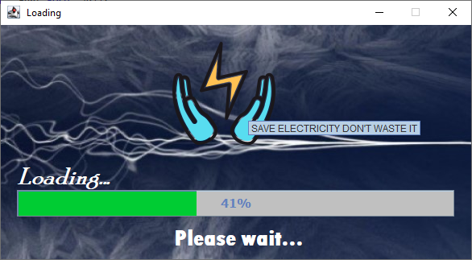

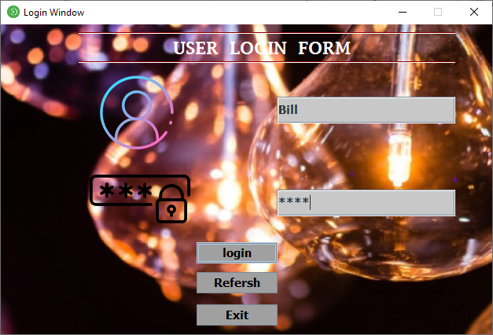

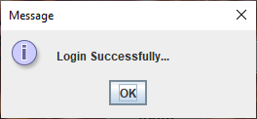

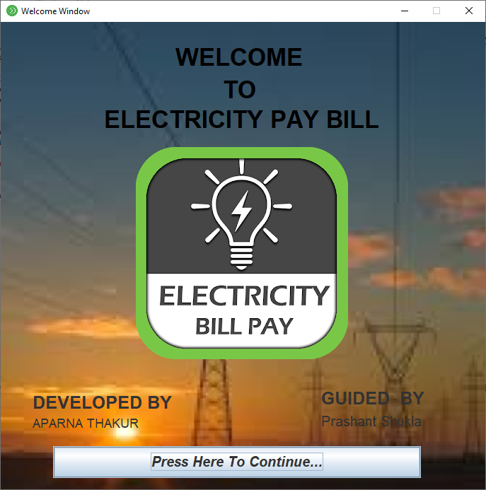

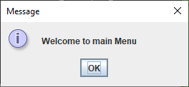

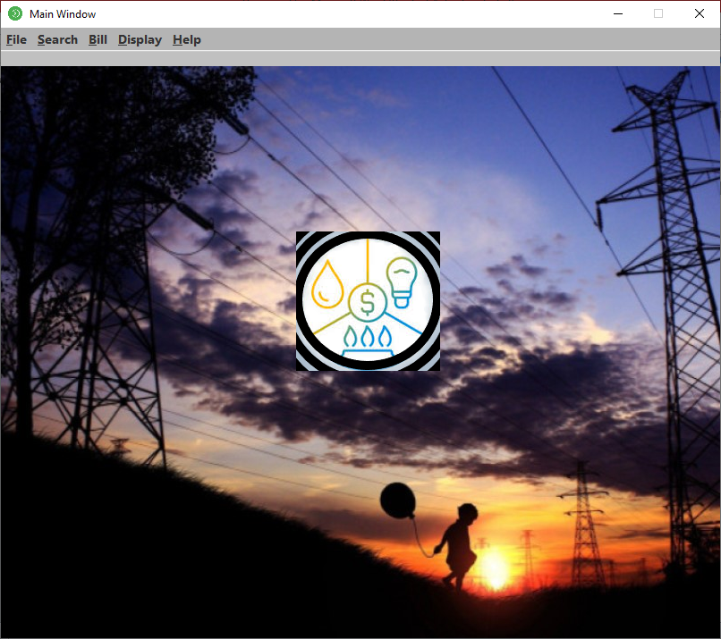

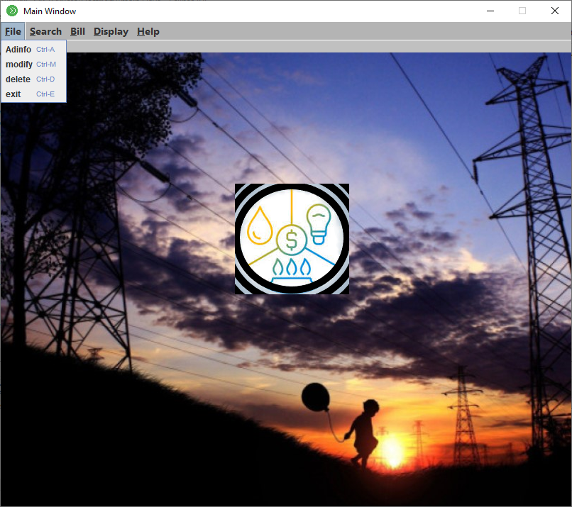

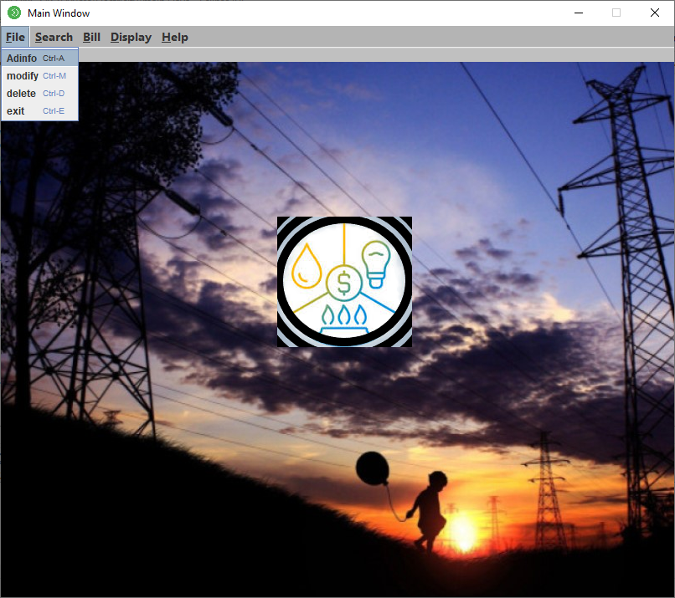

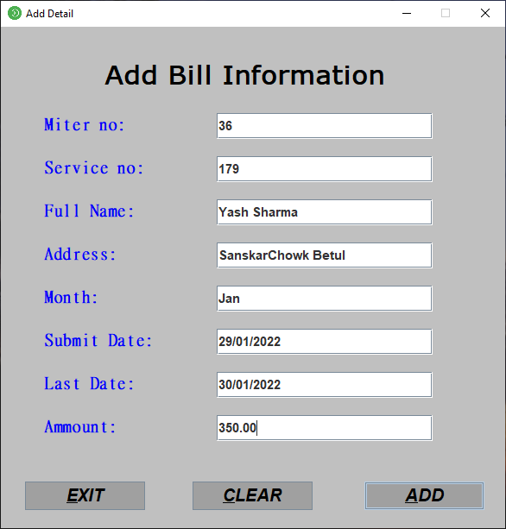

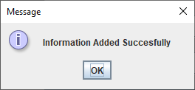

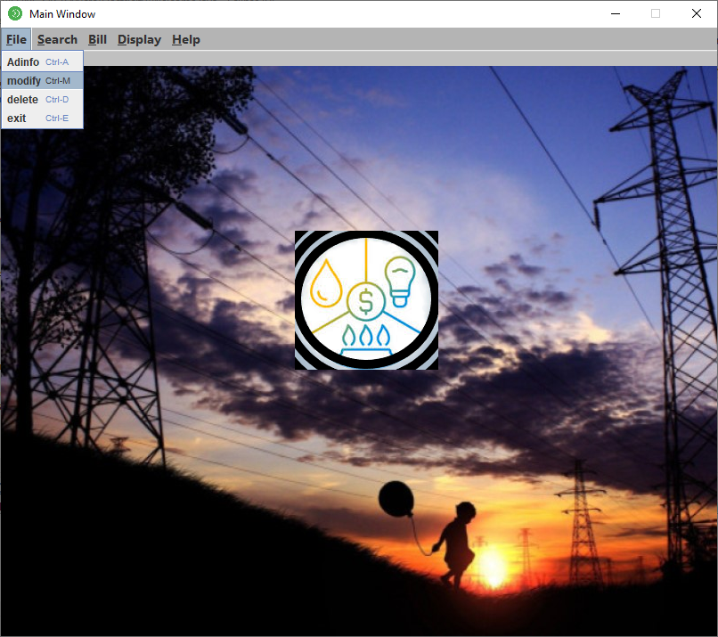

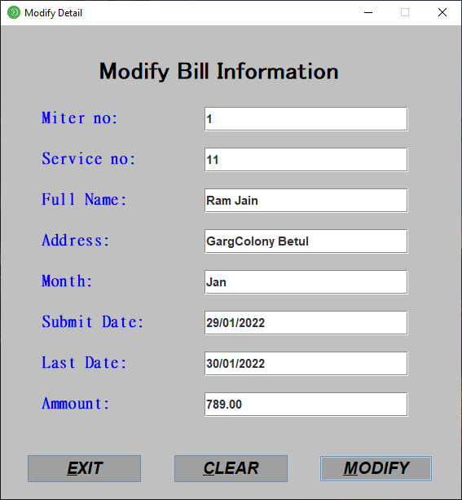

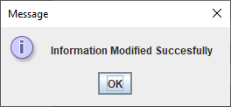

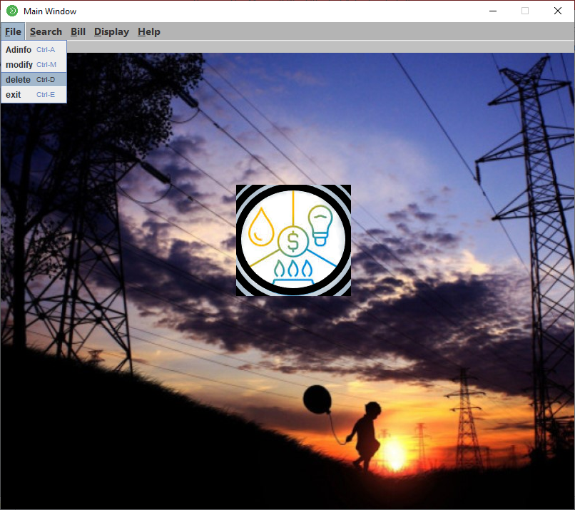

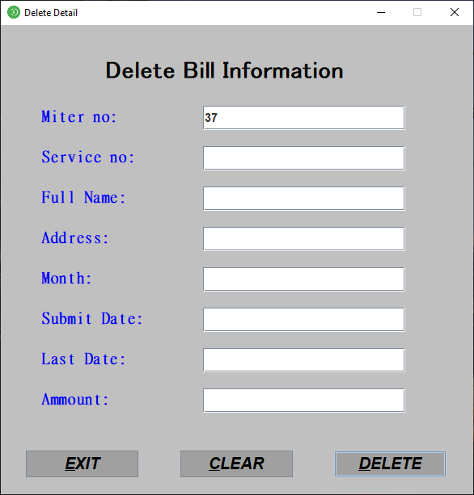

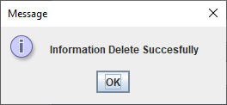

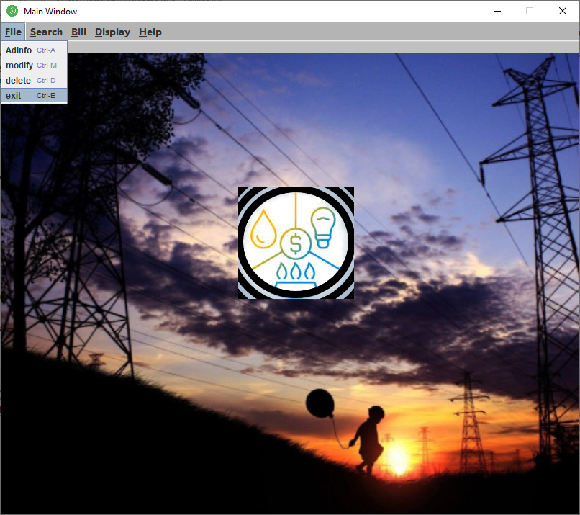

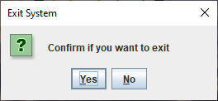

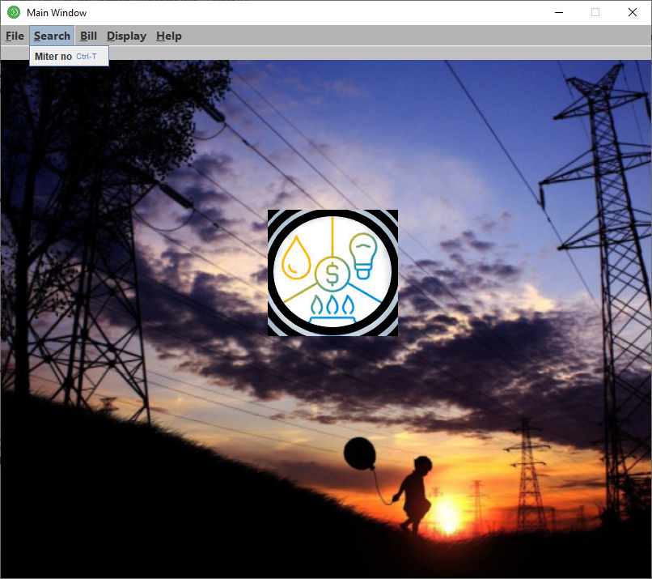

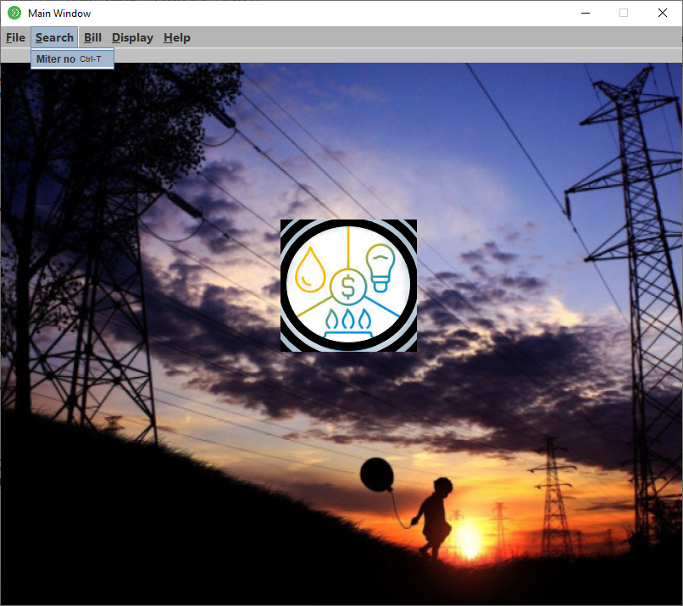

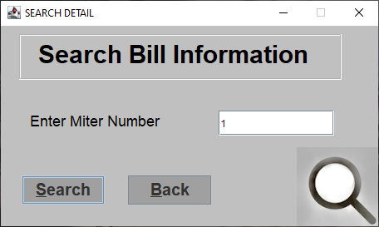

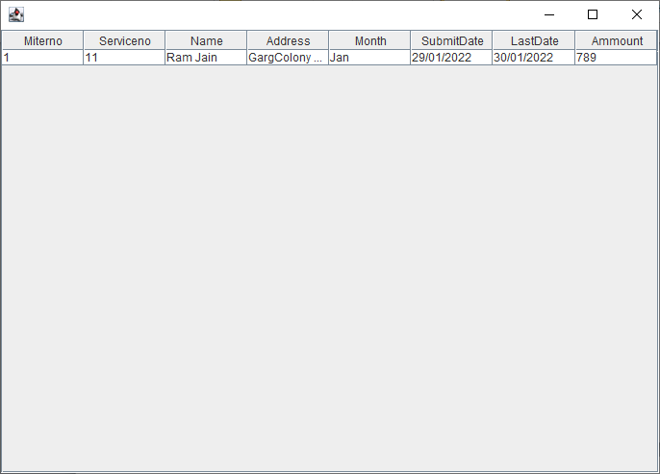

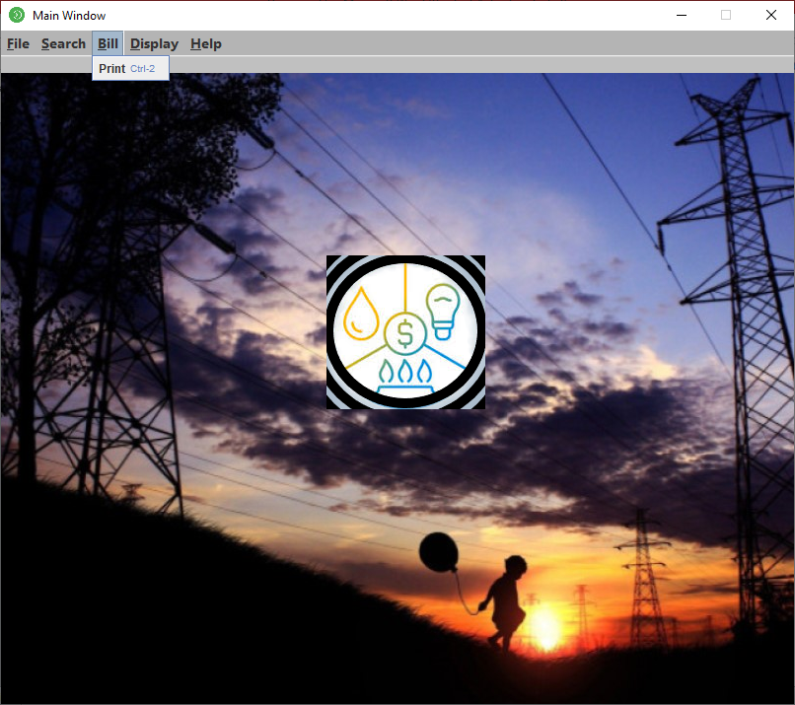

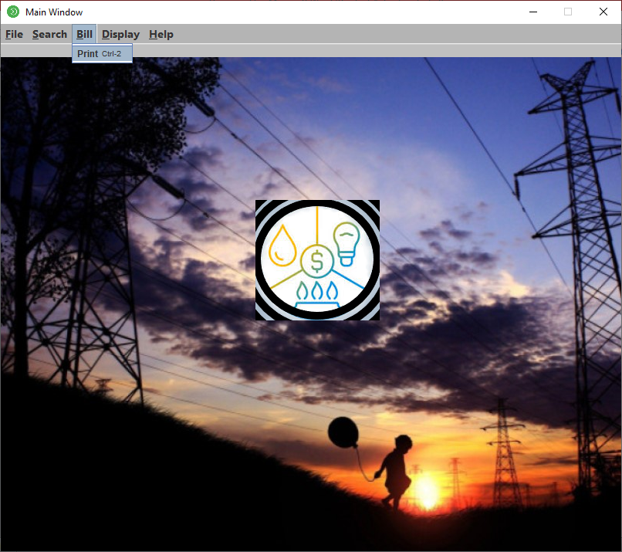

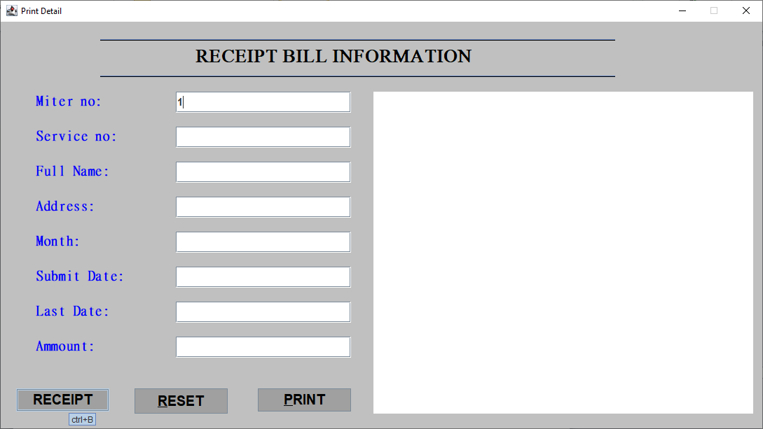

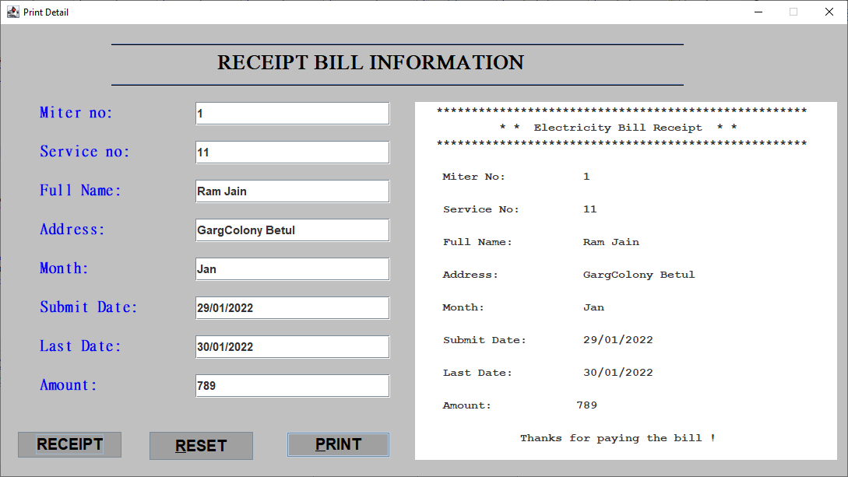

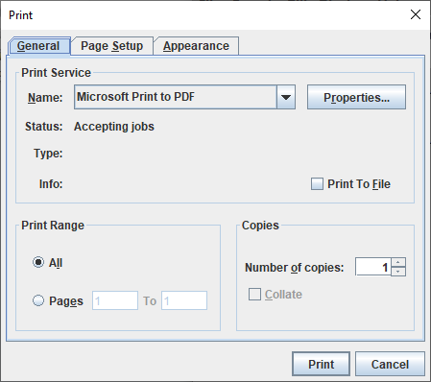

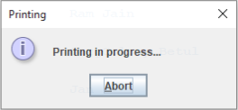

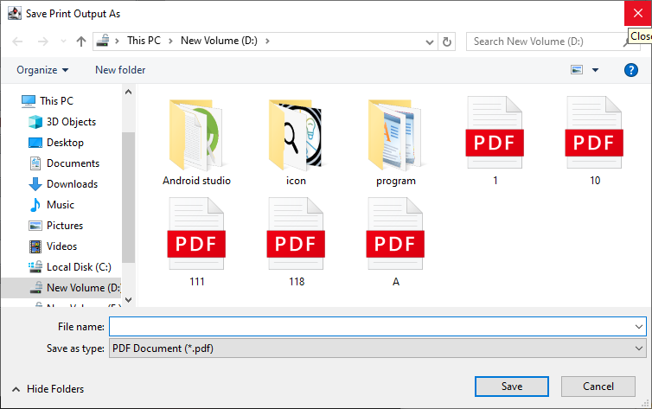

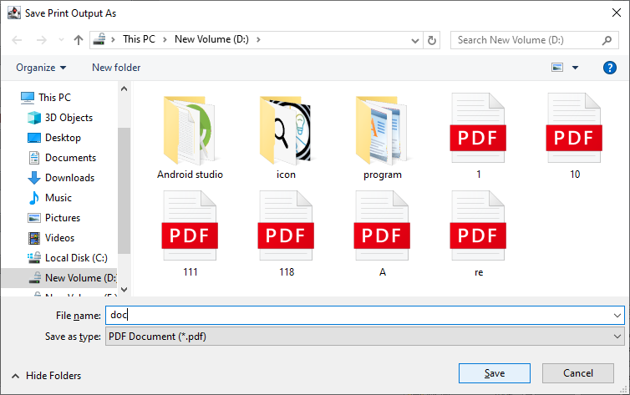

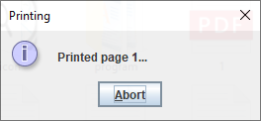

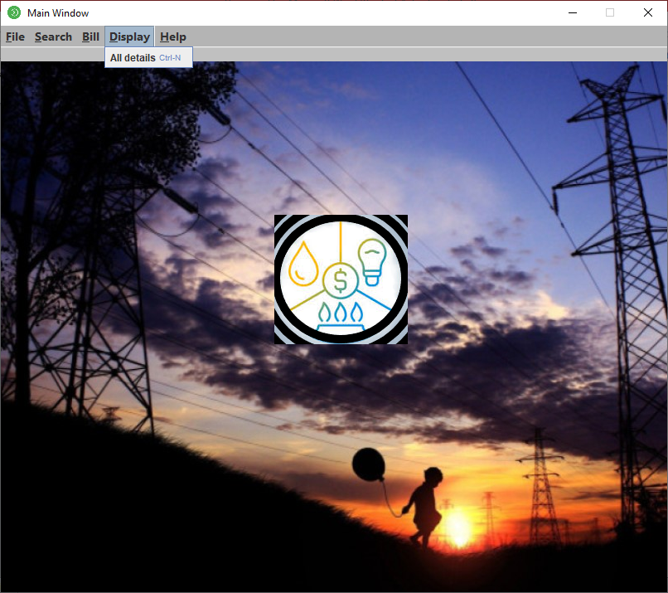

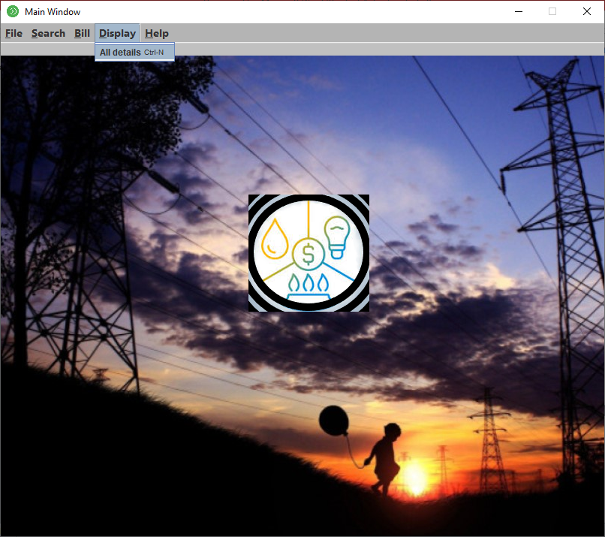

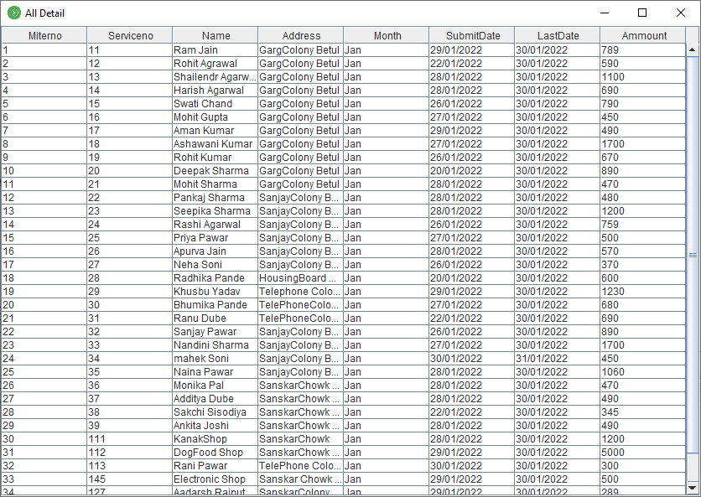

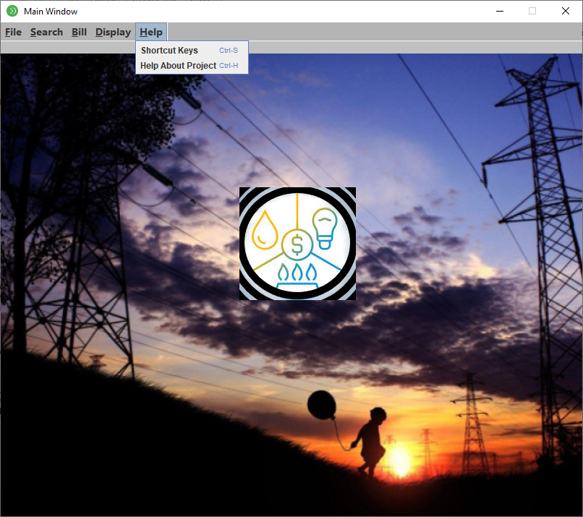

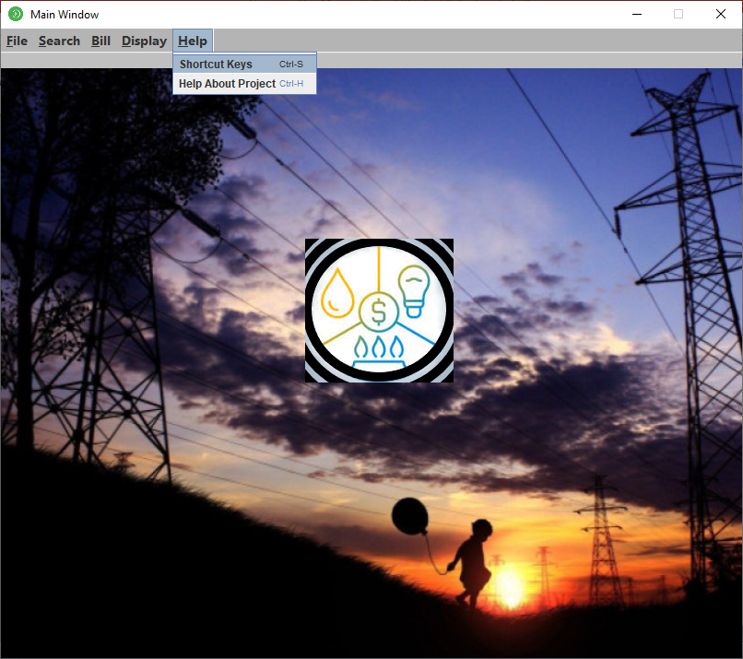

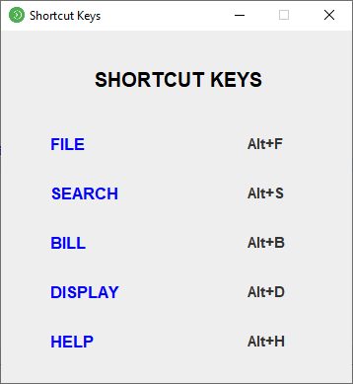

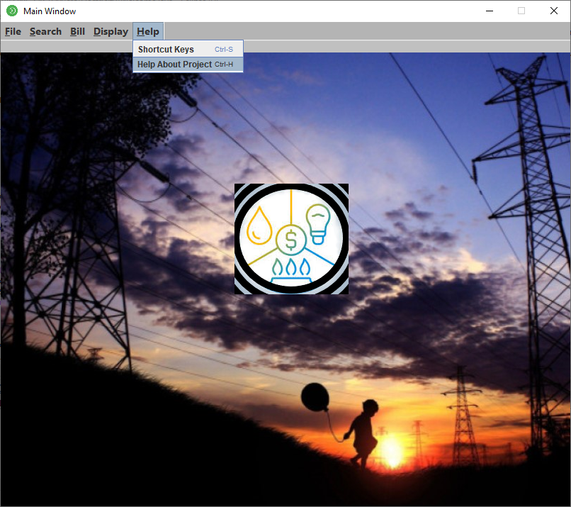

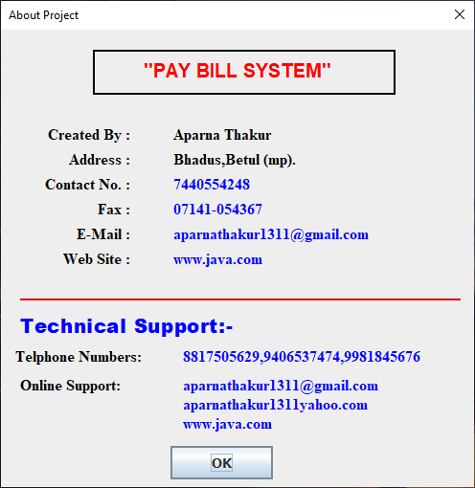

**Form 1**

package Electricity;

import javax.swing.*;

import java.awt.event.*;

import java.awt.*;

import java.sql.*;

public class Loading extends JFrame

{

JProgressBar jb;

Container c;

JLabel lb1,lb2,lb3,img;

int i=0,num=0;

Loading()

{

setFont(new Font("Dialog", Font.BOLD, 20));

setBackground(new Color(25, 25, 112));

setForeground(Color.GRAY);

setTitle(" Loading");

getContentPane().setBackground(new Color(175, 238, 238));

c=getContentPane();

c.setLayout(null);

jb= new JProgressBar(0,2000);

jb.setFont(new Font("Tahoma", Font.BOLD, 15));

jb.setForeground(new Color(0, 204, 51));

jb.setBackground(new Color(192, 192, 192));

jb.setBounds(20,205,543,33);

jb.setValue(0);

jb.setStringPainted(true);

c.add(jb);

setSize(688,383);

lb1=new JLabel(new ImageIcon("icon/Electricity.png"));

lb1.setBounds(130, 10, 295, 150);

lb1.setToolTipText("SAVE ELECTRICITY DON'T WASTE IT");

c.add(lb1);

lb2 = new JLabel("Loading...");

lb2.setForeground(Color.WHITE);

lb2.setFont(new Font("Poor Richard", Font.BOLD | Font.ITALIC, 30));

lb2.setBackground(new Color(51, 204, 204));

lb2.setBounds(20, 171, 153, 33);

c.add(lb2);

lb3 = new JLabel(" Please wait...");

lb3.setForeground(Color.WHITE);

lb3.setFont(new Font("Tw Cen MT Condensed Extra Bold", Font.BOLD, 29));

lb3.setBackground(Color.white);

lb3.setBounds(208, 248, 200, 33);

c.add(lb3);

img = new JLabel("");

img.setIcon(new ImageIcon("icon\\wap4.jpg"));

img.setBounds(0, 0, 584, 291);

getContentPane().add(img);

setSize(600,330);

setVisible(true);

setLocation(450,200);

setResizable(false);

}

public void iterate()

{

while(i<=2000)

{

jb.setValue(i);

i=i+20;

try{

Thread.sleep(150);

}

catch(Exception e)

{

}

}

}

public static void main(String[] args)

{

Loading m =new Loading();

m.setVisible(true);

m.iterate();

m.setDefaultCloseOperation(JFrame.EXIT_ON_CLOSE);

Login we=new Login();

we.setVisible(true);

}

}

**Form 2**

package Electricity;

import java.sql.*;

import javax.swing.*;

import java.awt.event.*;

import java.awt.*;

public class Login extends JFrame implements ActionListener

{

JLabel lb1,lb2,lb3,img;

JTextField t1;

JPasswordField p1;

JButton b1,b2,b3;

Container c;

JSeparator sep1,sep2;

JFrame frame;

public Login()

{

setIconImage(Toolkit.getDefaultToolkit().getImage("icon\\sdata.png"));

setBackground(Color.BLACK);

getContentPane().setBackground(new Color(0, 153, 153));

c=getContentPane();

setTitle("Login Window");

c.setLayout(null);

lb1=new JLabel(" USER LOGIN FORM");

lb1.setBackground(Color.WHITE);

lb1.setIcon(null);

lb1.setBounds(212,10,282,39);

lb1.setForeground(SystemColor.WHITE);

lb1.setFont(new Font("Lucida Fax", Font.BOLD, 22));

c.add(lb1);

sep1=new JSeparator();

sep1.setForeground(new Color(139, 0, 0));

sep1.setBounds(99,10,479,9);

c.add(sep1);

sep2 = new JSeparator();

sep2.setForeground(new Color(139, 0, 0));

sep2.setBounds(99,47,479,9);

c.add(sep2);

lb2=new JLabel("");

lb2.setIcon(new ImageIcon("icon\\User.png"));

lb2.setBounds(109,60,166,104);

lb2.setToolTipText("Username");

c.add(lb2);

t1=new JTextField(30);

t1.setFont(new Font("Tahoma", Font.BOLD, 15));

t1.setBackground(SystemColor.scrollbar);

t1.setToolTipText("You must be Enter Username");

t1.setBounds(351,92,227,34);

c.add(t1);

lb3=new JLabel(new ImageIcon("icon\\Pass.png"));

lb3.setBounds(99,179,156,87);

lb3.setToolTipText("Password");

c.add(lb3);

p1=new JPasswordField(30);

p1.setFont(new Font("Tahoma", Font.BOLD, 15));

p1.setEchoChar('*');

p1.setBackground(SystemColor.scrollbar);

p1.setBounds(351,210,227,34);

p1.setToolTipText("You must be Enter Password");

c.add(p1);

b1=new JButton("login");

b1.setBackground(SystemColor.controlShadow);

b1.setBounds(249,277,103,27);

b1.setToolTipText("Login");

b1.setFont(new Font("Tahoma", Font.BOLD, 15));

b1.setForeground(new Color(0,0,0));

c.add(b1);

b3=new JButton("Exit");

b3.setFont(new Font("Tahoma", Font.BOLD, 15));

b3.setForeground(new Color(0,0,0));

b3.setBackground(SystemColor.controlShadow);

b3.setBounds(249,356,103,27);

b3.setToolTipText("Exit");

c.add(b3);

b2= new JButton("Refersh");

b2.setToolTipText("Refersh");

b2.setBackground(SystemColor.controlShadow);

b2.setForeground(new Color(0,0,0));

b2.setFont(new Font("Tahoma", Font.BOLD, 15));

b2.setBounds(249, 315, 103, 27);

c.add(b2);

img = new JLabel("");

img.setIcon(new ImageIcon("icon\\wap5.jpg"));

img.setBounds(-57, 0, 702, 398);

getContentPane().add(img);

setSize(641,433);

setVisible(true);

setLocation(400,100);

setResizable(false);

b1.addActionListener(this);

b2.addActionListener(this);

b3.addActionListener(this);

}

public void actionPerformed(ActionEvent e) {

try

{

Class.forName("com.mysql.cj.jdbc.Driver");

Connection con=DriverManager.getConnection("jdbc:mysql://localhost:3306/mydb","root","");

if(e.getSource()==b1)

{

String Username=t1.getText();

String password=p1.getText().toString();

String sql="select*from logtable where Username='"+Username+"' and password='"+password+"'";

Statement stmt=con.createStatement();

ResultSet rs=stmt.executeQuery(sql);

if(rs.next())

{

JOptionPane.showMessageDialog(null,"Login Successfully...");

Welcome wel=new Welcome();

setVisible(false);

wel.setVisible(true);

}

else {

JOptionPane.showMessageDialog(null,"Login UnSuccessfully...");

setVisible(false);

}

}

con.close();

if(e.getSource()==b2)

{

t1.setText("");

p1.setText("");

}

}

catch(Exception e1){}

if(e.getSource()==b3)

{

frame=new JFrame();

if(JOptionPane.showConfirmDialog(frame, "Confirm if you want to exit”,” Exit Window", JOptionPane.YES_NO_CANCEL_OPTION)==JOptionPane.YES_NO_CANCEL_OPTION)

{

System.exit(0);

}

}

}

public static void main (String[]args)

{

Login log =new Login();

log.setDefaultCloseOperation(JFrame.EXIT_ON_CLOSE);

}

}

**Form 3**

package Electricity;

import java.awt.*;

import javax.swing.*;

import java.awt.event.*;

public class Welcome extends JFrame implements ActionListener

{

Container c;

JLabel l1,l2,l3,l4,l5,l6,l7,l8,img;

JButton b1;

JSeparator s1;

Font f;

public Welcome()

{

setIconImage(Toolkit.getDefaultToolkit().getImage("icon\\sdata.png"));

getContentPane().setBackground(new Color(51, 204, 204));

c=getContentPane();

setTitle("Welcome Window");

c.setLayout(null);

l1=new JLabel(" WELCOME ");

l1.setForeground(new Color(0, 0, 0));

l1.setBounds(197,20,279,60);

l1.setFont(new Font("Arial",Font.BOLD,35));

c.add(l1);

l2=new JLabel("TO");

l2.setForeground(new Color(0,0,0));

l2.setBounds(314,66,53,60);

l2.setFont(new Font("Arial", Font.BOLD, 35));

c.add(l2);

l3=new JLabel("ELECTRICITY PAY BILL");

l3.setForeground(new Color(0,0,0));

l3.setBounds(146,106,483,65);

l3.setFont(new Font("Arial", Font.BOLD, 35));

s1 =new JSeparator();

s1.setBackground(new Color(0, 0, 139));

s1.setBounds(25,176,729,-14);

c.add(s1);

c.add(l3);

l4=new JLabel("DEVELOPED BY ");

l4.setBounds(45,522,242,34);

l4.setFont(new Font("Arial",Font.BOLD,25));

c.add(l4);

l5=new JLabel ("GUIDED BY");

l5.setBounds(453,511,176,45);

l5.setFont(new Font("Arial",Font.BOLD,25));

c.add(l5);

l6=new JLabel(" APARNA THAKUR");

l6.setBounds(35,548,176,40);

l6.setFont(new Font ("Arial",Font.PLAIN,18));

c.add(l6);

l7=new JLabel("Prashant Shukla");

l7.setBounds(453,548,200,34);

l7.setFont(new Font ("Arial",Font.PLAIN,20));

c.add(l7);

b1=new JButton("Press Here To Continue...");

b1.setBackground(UIManager.getColor("Button.shadow"));

b1.setMnemonic('G');

b1.setBounds(74,600,520,45);

b1.setFont(new Font("Arial",Font.ITALIC+Font.BOLD,20));

c.add(b1);

b1.addActionListener(this);

l8=new JLabel (new ImageIcon("icon/Ele.png"));

l8.setBounds(35,152,612,351);

c.add(l8);

img = new JLabel("");

img.setIcon(new ImageIcon("icon\\bac.jpg"));

img.setBounds(0, 0, 685, 661);

getContentPane().add(img);

setSize(701,700);

setLocation(320,30);

setResizable(false);

setVisible(true);

}

public void actionPerformed(ActionEvent e)

{

if(e.getSource()==b1)

{

JOptionPane.showMessageDialog(null,"Welcome to main Menu");

main2 ma=new main2();

setVisible(false);

ma.setVisible(true);

}

}

public static void main(String args[])

{

Welcome wo=new Welcome();

wo.setDefaultCloseOperation(JFrame.EXIT_ON_CLOSE);

}

}

**Form 4**

package Electricity;

import java.awt.*;

import javax.swing.*;

import java.awt.event.*;

import java.sql.*;

public class main2 extends JFrame implements ActionListener{

Container f1;

JMenuBar mb;

JMenu std,sr,h,dis,tech;

JMenuItem a,b,c,e,n,g,dt,h1,h2,d1,d2;

JLabel Ele,img;

JFrame frame;

public main2()

{

setIconImage(Toolkit.getDefaultToolkit().getImage("icon\\sdata.png"));

setBackground(SystemColor.activeCaptionBorder);

getContentPane().setBackground(Color.LIGHT_GRAY);

f1=getContentPane();

setTitle(" Main Window");

f1.setLayout(null);

Ele=new JLabel(new ImageIcon("icon/pay.png"));

Ele.setBackground(new Color(176, 196, 222));

Ele.setBounds(330, 201, 161, 156);

getContentPane().add(Ele);

img = new JLabel("");

img.setIcon(new ImageIcon("icon\\wap3.jpg"));

img.setBounds(-12, 0, 833, 679);

getContentPane().add(img);

mb=new JMenuBar();

mb.setBackground(SystemColor.activeCaptionBorder);

std=new JMenu("File");

std.setFont(new Font("Segoe UI", Font.BOLD, 14));

std.setMnemonic('F');

mb.add(std);

tech=new JMenu("Search");

tech.setFont(new Font("Segoe UI", Font.BOLD, 14));

tech.setMnemonic('S');

mb.add(tech);

sr=new JMenu("Bill");

sr.setFont(new Font("Segoe UI", Font.BOLD, 14));

sr.setMnemonic('B');

mb.add(sr);

dis=new JMenu("Display");

dis.setFont(new Font("Segoe UI", Font.BOLD, 14));

dis.setMnemonic('D');

mb.add(dis);

h=new JMenu("Help");

h.setFont(new Font("Segoe UI", Font.BOLD, 14));

h.setMnemonic('H');

mb.add(h);

a=new JMenuItem("Adinfo");

a.setAccelerator(KeyStroke.getKeyStroke(KeyEvent.VK_A,Event.CTRL_MASK));

std.add(a);

b=new JMenuItem("modify");

b.setAccelerator(KeyStroke.getKeyStroke(KeyEvent.VK_M,Event.CTRL_MASK));

std.add(b);

c=new JMenuItem("delete");

c.setAccelerator(KeyStroke.getKeyStroke(KeyEvent.VK_D,Event.CTRL_MASK));

std.add(c);

e=new JMenuItem("exit");

e.setAccelerator(KeyStroke.getKeyStroke(KeyEvent.VK_E,Event.CTRL_MASK));

std.add(e);

g=new JMenuItem("Print");

g.setAccelerator(KeyStroke.getKeyStroke(KeyEvent.VK_2,Event.CTRL_MASK));

sr.add(g);

dt=new JMenuItem("Miter no");

dt.setAccelerator(KeyStroke.getKeyStroke(KeyEvent.VK_T,Event.CTRL_MASK));

tech.add(dt);

d1=new JMenuItem("All details");

d1.setAccelerator(KeyStroke.getKeyStroke(KeyEvent.VK_N,Event.CTRL_MASK));

dis.add(d1);

h1=new JMenuItem("Shortcut Keys");

h1.setAccelerator(KeyStroke.getKeyStroke(KeyEvent.VK_S,Event.CTRL_MASK));

h.add(h1);

h2=new JMenuItem("Help About Project");

h2.setAccelerator(KeyStroke.getKeyStroke(KeyEvent.VK_H,Event.CTRL_MASK));

h.add(h2);

setJMenuBar(mb);

a.addActionListener(this);

b.addActionListener(this);

c.addActionListener(this);

e.addActionListener(this);

g.addActionListener(this);

dt.addActionListener(this);

d1.addActionListener(this);

h1.addActionListener(this);

h2.addActionListener(this);

setSize(820,722);

setLocation(250,10);

setVisible(true);

setResizable(false);

}

public void actionPerformed(ActionEvent ae)

{

if(ae.getSource()==a)

{

setVisible(true);

adinfo ad=new adinfo();

ad.setVisible(true);

}

if(ae.getSource()==b)

{

setVisible(true);

modinfo md=new modinfo();

md.setVisible(true);

}

if(ae.getSource()==c)

{

setVisible(true);

delete dt=new delete();

dt.setVisible(true);

}

if(ae.getSource()==e)

{

frame=new JFrame();

if(JOptionPane.showConfirmDialog(frame, "Confirm if you want to exit","Exit System", JOptionPane.YES_NO_OPTION)==JOptionPane.YES_NO_OPTION)

{

System.exit(0);

}

}

if(ae.getSource()==dt)

{

setVisible(true);

Search s=new Search();

s.setVisible(true);

}

if(ae.getSource()==d1)

{

setVisible(true);

Display1 d=new Display1();

d.setVisible(true);

}

if(ae.getSource()==h1)

{

setVisible(true);

Help2 he=new Help2();

he.setVisible(true);

}

if(ae.getSource()==h2)

{

setVisible(true);

Projecthelp po=new Projecthelp();

po.setVisible(false);

}

if(ae.getSource()==g)

{

setVisible(true);

print e =new print();

e.setVisible(true);

}

}

}

**Form 5**

package Electricity;

import java.awt.*;

import java.awt.event.*;

import javax.swing.*;

import java.sql.*;

public class adinfo extends JFrame implements ActionListener{

JLabel l1,l2,l3,l4,l5,l6,l7,l8,l9;

JTextField t1,t2,t3,t4,t5,t6,t7,t8;

JButton b1,b2,b3;

Container c;

JComboBox t;

Font f;

Connection conn;

Statement stm;

public adinfo() {

setIconImage(Toolkit.getDefaultToolkit().getImage("icon\\sdata.png"));

getContentPane().setBackground(Color.LIGHT_GRAY);

setTitle("Add Detail");

c=getContentPane();

c.setLayout(null);

l1=new JLabel("Miter no:");

l1.setBounds(50,100,200,30);

l1.setFont(new Font("MingLiU_HKSCS-ExtB", Font.BOLD, 20));

l1.setForeground(Color.BLUE);

c.add(l1);

t1=new JTextField(30);

t1.setToolTipText("Add Miter Number");

t1.setBounds(250,100,250,30);

t1.setFont(new Font("Arial",Font.BOLD,15));

c.add(t1);

l2=new JLabel("Service no:");

l2.setBounds(50,150,200,30);

l2.setFont(new Font("MingLiU_HKSCS-ExtB", Font.BOLD, 20));

l2.setForeground(Color.blue);

c.add(l2);

t2=new JTextField(30);

t2.setToolTipText("Add Service Number");

t2.setBounds(250,150,250,30);

t2.setFont(new Font("Arial",Font.BOLD,15));

c.add(t2);

l3=new JLabel("Full Name:");

l3.setBounds(50,200,200,30);

l3.setFont(new Font("MingLiU_HKSCS-ExtB", Font.BOLD, 20));

l3.setForeground(Color.blue);

c.add(l3);

t3=new JTextField(30);

t3.setToolTipText("Add Full Name");

t3.setBounds(250,200,250,30);

t3.setFont(new Font("Arial",Font.BOLD,15));

c.add(t3);

l4=new JLabel("Address:");

l4.setBounds(50,250,200,30);

l4.setFont(new Font("MingLiU_HKSCS-ExtB", Font.BOLD, 20));

l4.setForeground(Color.blue);

c.add(l4);

t4=new JTextField(30);

t4.setToolTipText("Add Address");

t4.setBounds(250,250,250,30);

t4.setFont(new Font("Arial",Font.BOLD,15));

c.add(t4);

l5=new JLabel("Month:");

l5.setBounds(50,300,200,30);

l5.setFont(new Font("MingLiU_HKSCS-ExtB", Font.BOLD, 20));

l5.setForeground(Color.blue);

c.add(l5);

t5=new JTextField(30);

t5.setToolTipText("Add Month");

t5.setBounds(250,300,250,30);

t5.setFont(new Font("Arial",Font.BOLD,15));

c.add(t5);

l6=new JLabel("Submit Date:");

l6.setBounds(50,350,200,30);

l6.setFont(new Font("MingLiU_HKSCS-ExtB", Font.BOLD, 20));

l6.setForeground(Color.blue);

c.add(l6);

t6=new JTextField(30);

t6.setToolTipText("Add Submit Date");

t6.setBounds(250,350,250,30);

t6.setFont(new Font("Arial",Font.BOLD,15));

c.add(t6);

l7=new JLabel("Last Date:");

l7.setBounds(50,400,200,30);

l7.setFont(new Font("MingLiU_HKSCS-ExtB", Font.BOLD, 20));

l7.setForeground(Color.blue);

c.add(l7);

t7=new JTextField(30);

t7.setToolTipText("Add Last Date");

t7.setBounds(250,400,250,30);

t7.setFont(new Font("Arial",Font.BOLD,15));

c.add(t7);

l8=new JLabel("Ammount:");

l8.setBounds(50,450,200,30);

l8.setFont(new Font("MingLiU_HKSCS-ExtB", Font.BOLD, 20));

l8.setForeground(Color.blue);

c.add(l8);

t8=new JTextField(30);

t8.setToolTipText("Add Ammount");

t8.setBounds(250,450,250,30);

t8.setFont(new Font("Arial",Font.BOLD,15));

c.add(t8);

l9=new JLabel("Add Bill Information");

l9.setBackground(Color.WHITE);

l9.setBounds(120,40,380,30);

l9.setFont(new Font("MS Reference Sans Serif", Font.BOLD, 30));

l9.setForeground(SystemColor.desktop);

c.add(l9);

b1=new JButton("ADD");

b1.setBackground(SystemColor.controlShadow);

b1.setBounds(421,527,139,33);

b1.setFont(new Font("Arial",Font.BOLD+Font.ITALIC,20));

b1.setForeground(new Color(0, 0, 0));

b1.setMnemonic('A');

c.add(b1);

b2=new JButton("CLEAR");

b2.setBackground(SystemColor.controlShadow);

b2.setBounds(222,527,139,33);

b2.setFont(new Font("Arial",Font.BOLD+Font.ITALIC,20));

b2.setForeground(Color.black);

b2.setMnemonic('C');

c.add(b2);

b3=new JButton("EXIT");

b3.setBackground(SystemColor.controlShadow);

b3.setBounds(28,527,139,33);

b3.setFont(new Font("Arial",Font.BOLD+Font.ITALIC,20));

b3.setForeground(new Color(0, 0, 0));

b3.setMnemonic('E');

c.add(b3);

b1.addActionListener(this);

b2.addActionListener(this);

b3.addActionListener(this);

setSize(600,620);

setLocation(350,90);

setResizable(false);

setVisible(true);

}

public void actionPerformed(ActionEvent ae)

{

String s1=(t1.getText());

String s2=(t2.getText());

String s3=(t3.getText());

String s4=(t4.getText());

String s5=(t5.getText());

String s6=(t6.getText());

String s7=(t7.getText());

String s8=(t8.getText());

if(ae.getSource()==b1)

{

try

{

Class.forName("com.mysql.cj.jdbc.Driver");

conn=DriverManager.getConnection("jdbc:mysql://localhost:3306/mydb","root","");

String q ="insert into customer__info values('"+s1+"','"+s2+"','"+s3+"','"+s4+"','"+s5+"','"+s6+"','"+s7+"','"+s8+"') ";

stm=conn.createStatement();

stm.executeUpdate(q);

stm.close();

conn.close();

t1.setText("");

t2.setText("");

t3.setText("");

t4.setText("");

t5.setText("");

t6.setText("");

t7.setText("");

t8.setText("");

}

catch(Exception e)

{

e.printStackTrace();

}

JOptionPane.showMessageDialog(null, "Information Added Succesfully");

}

if(ae.getSource()==b2)

{

t1.setText("");

t2.setText("");

t3.setText("");

t4.setText("");

t5.setText("");

t6.setText("");

t7.setText("");

t8.setText("");

}

if(ae.getSource()==b3)

{

setVisible(false);

}

}

public static void main(String arge[])

{

adinfo ad=new adinfo();

ad.setDefaultCloseOperation(JFrame.EXIT_ON_CLOSE);

}

}

**Form 6**

package Electricity;

import java.awt.*;

import java.awt.event.*;

import javax.swing.*;

import java.sql.*;

public class modinfo extends JFrame implements ActionListener,FocusListener{

JLabel l1,l2,l3,l4,l5,l6,l7,l8,l9;

JTextField t1,t2,t3,t4,t5,t6,t7,t8;

JButton b1,b2,b3;

Container c;

JComboBox t;

Font f;

Connection conn;

Statement stm;

public modinfo() {

setIconImage(Toolkit.getDefaultToolkit().getImage("icon\\sdata.png"));

getContentPane().setBackground(Color.LIGHT_GRAY);

setTitle("Modify Detail");

c=getContentPane();

c.setLayout(null);

l1=new JLabel("Miter no:");

l1.setBounds(50,100,200,30);

l1.setFont(new Font("MingLiU_HKSCS-ExtB", Font.BOLD, 20));

l1.setForeground(Color.BLUE);

c.add(l1);

t1=new JTextField(30);

t1.setToolTipText("Add Miter Number");

t1.setBounds(250,100,250,30);

t1.setFont(new Font("Arial",Font.BOLD,15));

c.add(t1);

l2=new JLabel("Service no:");

l2.setBounds(50,150,200,30);

l2.setFont(new Font("MingLiU_HKSCS-ExtB", Font.BOLD, 20));

l2.setForeground(Color.blue);

c.add(l2);

t2=new JTextField(30);

t2.setToolTipText("Add Service Number");

t2.setBounds(250,150,250,30);

t2.setFont(new Font("Arial",Font.BOLD,15));

c.add(t2);

l3=new JLabel("Full Name:");

l3.setBounds(50,200,200,30);

l3.setFont(new Font("MingLiU_HKSCS-ExtB", Font.BOLD, 20));

l3.setForeground(Color.blue);

c.add(l3);

t3=new JTextField(30);

t3.setToolTipText("Add Full Name");

t3.setBounds(250,200,250,30);

t3.setFont(new Font("Arial",Font.BOLD,15));

c.add(t3);

l4=new JLabel("Address:");

l4.setBounds(50,250,200,30);

l4.setFont(new Font("MingLiU_HKSCS-ExtB", Font.BOLD, 20));

l4.setForeground(Color.blue);

c.add(l4);

t4=new JTextField(30);

t4.setToolTipText("Add Address");

t4.setBounds(250,250,250,30);

t4.setFont(new Font("Arial",Font.BOLD,15));

c.add(t4);

l5=new JLabel("Month:");

l5.setBounds(50,300,200,30);

l5.setFont(new Font("MingLiU_HKSCS-ExtB", Font.BOLD, 20));

l5.setForeground(Color.blue);

c.add(l5);

t5=new JTextField(30);

t5.setToolTipText("Add Month");

t5.setBounds(250,300,250,30);

t5.setFont(new Font("Arial",Font.BOLD,15));

c.add(t5);

l6=new JLabel("Submit Date:");

l6.setBounds(50,350,200,30);

l6.setFont(new Font("MingLiU_HKSCS-ExtB", Font.BOLD, 20));

l6.setForeground(Color.blue);

c.add(l6);

t6=new JTextField(30);

t6.setToolTipText("Add Submit Date");

t6.setBounds(250,350,250,30);

t6.setFont(new Font("Arial",Font.BOLD,15));

c.add(t6);

l7=new JLabel("Last Date:");

l7.setBounds(50,400,200,30);

l7.setFont(new Font("MingLiU_HKSCS-ExtB", Font.BOLD, 20));

l7.setForeground(Color.blue);

c.add(l7);

t7=new JTextField(30);

t7.setToolTipText("Add Last Date");

t7.setBounds(250,400,250,30);

t7.setFont(new Font("Arial",Font.BOLD,15));

c.add(t7);

l8=new JLabel("Ammount:");

l8.setBounds(50,450,200,30);

l8.setFont(new Font("MingLiU_HKSCS-ExtB", Font.BOLD, 20));

l8.setForeground(Color.blue);

c.add(l8);

t8=new JTextField(30);

t8.setToolTipText("Add Ammount");

t8.setBounds(250,450,250,30);

t8.setFont(new Font("Arial",Font.BOLD,15));

c.add(t8);

l9=new JLabel("Modify Bill Information");

l9.setBackground(Color.WHITE);

l9.setBounds(120,40,380,30);

l9.setFont(new Font("MS UI Gothic", Font.BOLD, 30));

l9.setForeground(SystemColor.desktop);

c.add(l9);

b1=new JButton("MODIFY");

b1.setBackground(SystemColor.controlShadow);

b1.setBounds(391,527,139,33);

b1.setFont(new Font("Arial",Font.BOLD+Font.ITALIC,20));

b1.setForeground(new Color(0, 0, 0));

b1.setMnemonic('M');

c.add(b1);

b2=new JButton("CLEAR");

b2.setBackground(SystemColor.controlShadow);

b2.setBounds(213,527,139,33);

b2.setFont(new Font("Arial",Font.BOLD+Font.ITALIC,20));

b2.setForeground(Color.black);

b2.setMnemonic('C');

c.add(b2);

b3=new JButton("EXIT");

b3.setBackground(SystemColor.controlShadow);

b3.setBounds(33,527,139,33);

b3.setFont(new Font("Arial",Font.BOLD+Font.ITALIC,20));

b3.setForeground(new Color(0, 0, 0));

b3.setMnemonic('E');

c.add(b3);

b1.addActionListener(this);

b2.addActionListener(this);

b3.addActionListener(this);

t2.addFocusListener(this);

setSize(581,620);

setLocation(350,90);

setResizable(false);

setVisible(true);

}

public void foucusGained(FocusEvent f)

{

Connection con;

Statement st;

ResultSet rs;

String sq;

try

{

Class.forName("com.mysql.cj.jdbc.Driver");

con=DriverManager.getConnection("jdbc:mysql://localhost:3306/mydb","root","");

st=con.createStatement();

String s1=t1.getText();

sq=("select*from customer__info where Miterno='"+s1+"'");

rs=st.executeQuery(sq);

while(rs.next())

{

t2.setText(rs.getString(2));

t3.setText(rs.getString(3));

t4.setText(rs.getString(4));

t5.setText(rs.getString(5));

t6.setText(rs.getString(6));

t7.setText(rs.getString(7));

t8.setText(rs.getString(8));

break;

}

}

catch(Exception e)

{ }

}

public void focusLost(FocusEvent f)

{

}

public void focusGained(FocusEvent f2)

{

}

public void actionPerformed(ActionEvent ae)

{

String s1=(t1.getText());

String s2=(t2.getText());

String s3=(t3.getText());

String s4=(t4.getText());

String s5=(t5.getText());

String s6=(t6.getText());

String s7=(t7.getText());

String s8=(t8.getText());

if(ae.getSource()==b1)

{

try

{

Class.forName("com.mysql.cj.jdbc.Driver");

conn=DriverManager.getConnection("jdbc:mysql://localhost:3306/mydb","root","");

String q =("update customer__info set Miterno='"+s1+"',Serviceno='"+s2+"',FullName='"+s3+"',Address='"+s4+"',Month='"+s5+"',SubmitDate='"+s6+"',LastDate='"+s7+"',Ammount='"+s8+"'where Miterno='"+s1+"'");

stm=conn.createStatement();

stm.executeUpdate(q);

stm.close();

conn.close();

t1.setText("");

t2.setText("");

t3.setText("");

t4.setText("");

t5.setText("");

t6.setText("");

t7.setText("");

t8.setText("");

}

catch(Exception e)

{

e.printStackTrace();

}

JOptionPane.showMessageDialog(null, "Information Modified Succesfully");

}

if(ae.getSource()==b2)

{

t1.setText("");

t2.setText("");

t3.setText("");

t4.setText("");

t5.setText("");

t6.setText("");

t7.setText("");

t8.setText("");

}

if(ae.getSource()==b3)

{

setVisible(false);

}

try

{

Class.forName("com.mysql.cj.jdbc.Driver");

Connection conn1=DriverManager.getConnection("jdbc:mysql://localhost:3306/mydb","root","");

Statement stm1=conn1.createStatement();

String s11=t1.getText();

String q =("select*from customer__info where Miterno='"+s11+"'");

ResultSet r =stm1.executeQuery(q);

while(r.next())

{

String s21=r.getString(2);

String s31=r.getString(3);

String s41=r.getString(4);

String s51=r.getString(5);

String s61=r.getString(6);

String s71=r.getString(7);

String s81=r.getString(8);

if(ae.getSource()==b1)

{

s11=t1.getText();

s21=t2.getText();

s31=t3.getText();

s41=t4.getText();

s51=t5.getText();

s61=t6.getText();

s71=t7.getText();

s81=t8.getText();

}

}

}

catch(Exception a) {

a.printStackTrace();

}

}

public static void main(String arge[])

{

modinfo md=new modinfo();

md.setDefaultCloseOperation(JFrame.EXIT_ON_CLOSE);

}

**Form 7**

package Electricity;

import java.awt.*;

import java.awt.event.*;

import javax.swing.*;

import java.sql.*;

public class delete extends JFrame implements ActionListener,FocusListener{

JLabel l1,l2,l3,l4,l5,l6,l7,l8,l9;

JTextField t1,t2,t3,t4,t5,t6,t7,t8;

JButton b1,b2,b3;

Container c;

JComboBox t;

Font f;

Connection conn;

Statement stm;

public delete() {

setIconImage(Toolkit.getDefaultToolkit().getImage("icon\\sdata.png"));

getContentPane().setBackground(Color.LIGHT_GRAY);

setTitle("Delete Detail");

c=getContentPane();

c.setLayout(null);

l1=new JLabel("Miter no:");

l1.setBounds(50,100,200,30);

l1.setFont(new Font("MingLiU_HKSCS-ExtB", Font.BOLD, 20));

l1.setForeground(Color.BLUE);

c.add(l1);

t1=new JTextField(30);

t1.setToolTipText("Add Miter Number");

t1.setBounds(250,100,250,30);

t1.setFont(new Font("Arial",Font.BOLD,15));

c.add(t1);

l2=new JLabel("Service no:");

l2.setBounds(50,150,200,30);

l2.setFont(new Font("MingLiU_HKSCS-ExtB", Font.BOLD, 20));

l2.setForeground(Color.blue);

c.add(l2);

t2=new JTextField(30);

t2.setToolTipText("");

t2.setBounds(250,150,250,30);

t2.setFont(new Font("Arial",Font.BOLD,15));

c.add(t2);

l3=new JLabel("Full Name:");

l3.setBounds(50,200,200,30);

l3.setFont(new Font("MingLiU_HKSCS-ExtB", Font.BOLD, 20));

l3.setForeground(Color.blue);

c.add(l3);

t3=new JTextField(30);

t3.setToolTipText("");

t3.setBounds(250,200,250,30);

t3.setFont(new Font("Arial",Font.BOLD,15));

c.add(t3);

l4=new JLabel("Address:");

l4.setBounds(50,250,200,30);

l4.setFont(new Font("MingLiU_HKSCS-ExtB", Font.BOLD, 20));

l4.setForeground(Color.blue);

c.add(l4);

t4=new JTextField(30);

t4.setToolTipText("");

t4.setBounds(250,250,250,30);

t4.setFont(new Font("Arial",Font.BOLD,15));

c.add(t4);

l5=new JLabel("Month:");

l5.setBounds(50,300,200,30);

l5.setFont(new Font("MingLiU_HKSCS-ExtB", Font.BOLD, 20));

l5.setForeground(Color.blue);

c.add(l5);

t5=new JTextField(30);

t5.setToolTipText("");

t5.setBounds(250,300,250,30);

t5.setFont(new Font("Arial",Font.BOLD,15));

c.add(t5);

l6=new JLabel("Submit Date:");

l6.setBounds(50,350,200,30);

l6.setFont(new Font("MingLiU_HKSCS-ExtB", Font.BOLD, 20));

l6.setForeground(Color.blue);

c.add(l6);

t6=new JTextField(30);

t6.setToolTipText("");

t6.setBounds(250,350,250,30);

t6.setFont(new Font("Arial",Font.BOLD,15));

c.add(t6);

l7=new JLabel("Last Date:");

l7.setBounds(50,400,200,30);

l7.setFont(new Font("MingLiU_HKSCS-ExtB", Font.BOLD, 20));

l7.setForeground(Color.blue);

c.add(l7);

t7=new JTextField(30);

t7.setToolTipText("");

t7.setBounds(250,400,250,30);

t7.setFont(new Font("Arial",Font.BOLD,15));

c.add(t7);

l8=new JLabel("Ammount:");

l8.setBounds(50,450,200,30);

l8.setFont(new Font("MingLiU_HKSCS-ExtB", Font.BOLD, 20));

l8.setForeground(Color.blue);

c.add(l8);

t8=new JTextField(30);

t8.setToolTipText("");

t8.setBounds(250,450,250,30);

t8.setFont(new Font("Arial",Font.BOLD,15));

c.add(t8);

l9=new JLabel("Delete Bill Information");

l9.setBackground(Color.WHITE);

l9.setBounds(129,40,371,30);

l9.setFont(new Font("MS UI Gothic", Font.BOLD, 30));

l9.setForeground(SystemColor.desktop);

c.add(l9);

b1=new JButton("DELETE");

b1.setBackground(SystemColor.controlShadow);

b1.setBounds(412,527,139,33);

b1.setFont(new Font("Arial",Font.BOLD+Font.ITALIC,20));

b1.setForeground(new Color(0, 0, 0));

b1.setMnemonic('D');

c.add(b1);

b2=new JButton("CLEAR");

b2.setBackground(SystemColor.controlShadow);

b2.setBounds(222,527,139,33);

b2.setFont(new Font("Arial",Font.BOLD+Font.ITALIC,20));

b2.setForeground(Color.black);

b2.setMnemonic('C');

c.add(b2);

b3=new JButton("EXIT");

b3.setBackground(SystemColor.controlShadow);

b3.setBounds(31,527,139,33);

b3.setFont(new Font("Arial",Font.BOLD+Font.ITALIC,20));

b3.setForeground(new Color(0, 0, 0));

b3.setMnemonic('E');

c.add(b3);

b1.addActionListener(this);

b2.addActionListener(this);

b3.addActionListener(this);

t2.addFocusListener(this);

setSize(600,620);

setLocation(350,90);

setResizable(false);

setVisible(true);

}

public void foucusGained(FocusEvent f)

{

Connection con;

Statement st;

ResultSet rs;

String sq;

try

{

Class.forName("com.mysql.cj.jdbc.Driver");

con=DriverManager.getConnection("jdbc:mysql://localhost:3306/mydb","root","");

st=con.createStatement();

String s1=t1.getText();

sq=("select*from customer__info where Miterno='"+s1+"'");

rs=st.executeQuery(sq);

while(rs.next())

{

t2.setText(rs.getString(2));

t3.setText(rs.getString(3));

t4.setText(rs.getString(4));

t5.setText(rs.getString(5));

t6.setText(rs.getString(6));

t7.setText(rs.getString(7));

t8.setText(rs.getString(8));

break;

}

}

catch(Exception e)

{ }

}

public void focusLost(FocusEvent f)

{

}

public void focusGained(FocusEvent f2)

{

}

public void actionPerformed(ActionEvent ae)

{

String s1=(t1.getText());

String s2=(t2.getText());

String s3=(t3.getText());

String s4=(t4.getText());

String s5=(t5.getText());

String s6=(t6.getText());

String s7=(t7.getText());

String s8=(t8.getText());

if(ae.getSource()==b1)

{

try

{

Class.forName("com.mysql.cj.jdbc.Driver");

conn=DriverManager.getConnection("jdbc:mysql://localhost:3306/mydb","root","");

String q =("delete from customer__info where Miterno='"+s1+"'");

stm=conn.createStatement();

stm.executeUpdate(q);

stm.close();

conn.close();

t1.setText("");

t2.setText("");

t3.setText("");

t4.setText("");

t5.setText("");

t6.setText("");

t7.setText("");

t8.setText("");

}

catch(Exception e)

{

e.printStackTrace();

}

JOptionPane.showMessageDialog(null, "Information Delete Succesfully");

}

if(ae.getSource()==b2)

{

t1.setText("");

t2.setText("");

t3.setText("");

t4.setText("");

t5.setText("");

t6.setText("");

t7.setText("");

t8.setText("");

}

if(ae.getSource()==b3)

{

setVisible(false);

}

}

public static void main(String arge[])

{

delete dt=new delete();

dt.setDefaultCloseOperation(JFrame.EXIT_ON_CLOSE);

}

}

**Form 8**

package Electricity;

import java.awt.*;

import java.awt.event.*;

import javax.swing.*;

import java.sql.*;

public class Search extends JFrame implements ActionListener

{

JLabel lb1,lb2,lb3;

JButton btn1,btn2;

JTextField t1;

Container c;

Font f;

JSeparator sep1;

public Search() {

getContentPane().setBackground(Color.LIGHT_GRAY);

c=getContentPane();

setTitle("SEARCH DETAIL");

c.setLayout(null);

lb1=new JLabel(" Search Bill Information ");

lb1.setBounds(37,20,367,30);

lb1.setFont(new Font("Arial",Font.BOLD,30));

lb1.setForeground(Color.BLACK);

c.add(lb1);

sep1=new JSeparator();

sep1.setForeground(Color.BLACK);

sep1.setBounds(22,10,388,55);

c.add(sep1);

sep1.setBorder(BorderFactory.createEtchedBorder());

lb2=new JLabel("Enter Miter Number");

lb2.setBounds(35,100,181,30);

lb2.setFont(new Font("Arial", Font.PLAIN, 18));

lb2.setForeground(Color.BLACK);

c.add(lb2);

t1=new JTextField(30);

t1.setBounds(262,102,139,30);

c.add(t1);

lb3=new JLabel(new ImageIcon("icon/sr1.png"));

lb3.setForeground(Color.WHITE);

lb3.setBackground(Color.WHITE);

lb3.setBounds(356,146,100,97);

c.add(lb3);

btn1=new JButton("Search");

btn1.setBackground(SystemColor.controlShadow);

btn1.setBounds(25,180,100,35);

btn1.setFont(new Font("Arial", Font.BOLD, 20));

btn1.setMnemonic('S');

c.add(btn1);

btn2=new JButton("Back");

btn2.setBackground(SystemColor.controlShadow);

btn2.setBounds(153,180,100,35);

btn2.setFont(new Font("Arial", Font.BOLD, 20));

btn2.setMnemonic('B');

c.add(btn2);

btn1.addActionListener(this);

btn2.addActionListener(this);

setSize(470,280);

setVisible(true);

setLocation(300,250);

setResizable(false);

}

public void actionPerformed(ActionEvent ae)

{

if(ae.getSource()==btn2)

{

setVisible(false);

}

if(ae.getSource()==btn1)

{

String s=t1.getText();

setVisible(false);

Sdisp t=new Sdisp(s);

t.setSize(700,500);

t.setLocation(190,90);

t.setVisible(true);

}

}

public static void main(String arg[])

{

Search s=new Search();

s.setDefaultCloseOperation(JFrame.EXIT_ON_CLOSE);

}

}

**Form 9**

package Electricity;

import javax.swing.*;

import javax.swing.table.DefaultTableModel;

import java.awt.*;

import java.awt.event.*;

import java.sql.*;

public class Sdisp extends JFrame

{

Connection con;

Statement st;

Container c;

ResultSet rs;

String q;

public Sdisp(String tt)

{

String data[]=new String[8];

try

{

Class.forName("com.mysql.cj.jdbc.Driver");

con=DriverManager.getConnection("jdbc:mysql://localhost:3306/mydb","root","");

q=("select*from customer__info where Miterno='"+tt+"'");

st=con.createStatement();

rs=st.executeQuery(q);

c=getContentPane();

DefaultTableModel dm=new DefaultTableModel();

JTable tf=new JTable(dm);

for(int i=0;i<=8;i++)

{

if(i==0)

{

dm.addColumn("Miterno");

}

if(i==1)

{

dm.addColumn("Serviceno");

}

if(i==2)

{

dm.addColumn("Name");

}

if(i==3)

{

dm.addColumn("Address");

}

if(i==4)

{

dm.addColumn("Month");

}

if(i==5)

{

dm.addColumn("SubmitDate");

}

if(i==6)

{

dm.addColumn("LastDate");

}

if(i==7)

{

dm.addColumn("Ammount");

}

c.add(new JScrollPane(tf));

}

while(rs.next())

{

String s1=rs.getString(1);

String s2=rs.getString(2);

String s3=rs.getString(3);

String s4=rs.getString(4);

String s5=rs.getString(5);

String s6=rs.getString(6);

String s7=rs.getString(7);

String s8=rs.getString(8);

data[0]=s1;

data[1]=s2;

data[2]=s3;

data[3]=s4;

data[4]=s5;

data[5]=s6;

data[6]=s7;

data[7]=s8;

dm.addRow(data);

}

}

catch(Exception e){ }

}

public static void main(String args[])

{

Sdisp td=new Sdisp("101");

td.setSize(880,300);

td.setLocation(350,150);

td.setResizable(true);

td.setVisible(true);

}

}

**Form 10**

package Electricity;

import java.awt.*;

import java.awt.event.*;

import java.awt.print.PrinterException;

import javax.swing.*;

import java.sql.*;

import java.util.*;

import java.io.*;

public class print extends JFrame implements ActionListener,FocusListener{

JLabel l1,l2,l3,l4,l5,l6,l7,l8,l9;

JTextField t1,t2,t3,t4,t5,t6,t7,t8;

JButton b1,b2,b3;

Container c;

Font f;

Connection conn;

Statement stm;

JTextArea area;

JSeparator sep,sep2;

public print() {

getContentPane().setBackground(Color.LIGHT_GRAY);

setTitle("Print Detail");

c=getContentPane();

c.setLayout(null);

l1=new JLabel("Miter no:");

l1.setBounds(50,100,200,30);

l1.setFont(new Font("MingLiU_HKSCS-ExtB", Font.BOLD, 20));

l1.setForeground(Color.BLUE);

c.add(l1);

t1=new JTextField(30);

t1.setToolTipText("insert Miter no.");

t1.setBounds(250,100,250,30);

t1.setFont(new Font("Arial",Font.BOLD,15));

c.add(t1);

l2=new JLabel("Service no:");

l2.setBounds(50,150,200,30);

l2.setFont(new Font("MingLiU_HKSCS-ExtB", Font.BOLD, 20));

l2.setForeground(Color.blue);

c.add(l2);

t2=new JTextField(30);

t2.setToolTipText("");

t2.setBounds(250,150,250,30);

t2.setFont(new Font("Arial",Font.BOLD,15));

c.add(t2);

l3=new JLabel("Full Name:");

l3.setBounds(50,200,200,30);

l3.setFont(new Font("MingLiU_HKSCS-ExtB", Font.BOLD, 20));

l3.setForeground(Color.blue);

c.add(l3);

t3=new JTextField(30);

t3.setToolTipText("");

t3.setBounds(250,200,250,30);

t3.setFont(new Font("Arial",Font.BOLD,15));

c.add(t3);

l4=new JLabel("Address:");

l4.setBounds(50,250,200,30);

l4.setFont(new Font("MingLiU_HKSCS-ExtB", Font.BOLD, 20));

l4.setForeground(Color.blue);

c.add(l4);

t4=new JTextField(30);

t4.setToolTipText("");

t4.setBounds(250,250,250,30);

t4.setFont(new Font("Arial",Font.BOLD,15));

c.add(t4);

l5=new JLabel("Month:");

l5.setBounds(50,300,200,30);

l5.setFont(new Font("MingLiU_HKSCS-ExtB", Font.BOLD, 20));

l5.setForeground(Color.blue);

c.add(l5);

t5=new JTextField(30);

t5.setToolTipText("");

t5.setBounds(250,300,250,30);

t5.setFont(new Font("Arial",Font.BOLD,15));

c.add(t5);

l6=new JLabel("Submit Date:");

l6.setBounds(50,350,200,30);

l6.setFont(new Font("MingLiU_HKSCS-ExtB", Font.BOLD, 20));

l6.setForeground(Color.blue);

c.add(l6);

t6=new JTextField(30);

t6.setToolTipText("");

t6.setBounds(250,350,250,30);

t6.setFont(new Font("Arial",Font.BOLD,15));

c.add(t6);

l7=new JLabel("Last Date:");

l7.setBounds(50,400,200,30);

l7.setFont(new Font("MingLiU_HKSCS-ExtB", Font.BOLD, 20));

l7.setForeground(Color.blue);

c.add(l7);

t7=new JTextField(30);

t7.setToolTipText("");

t7.setBounds(250,400,250,30);

t7.setFont(new Font("Arial",Font.BOLD,15));

c.add(t7);

l8=new JLabel("Ammount:");

l8.setBounds(50,450,200,30);

l8.setFont(new Font("MingLiU_HKSCS-ExtB", Font.BOLD, 20));

l8.setForeground(Color.blue);

c.add(l8);

t8=new JTextField(30);

t8.setToolTipText("");

t8.setBounds(250,450,250,30);

t8.setFont(new Font("Arial",Font.BOLD,15));

c.add(t8);

l9=new JLabel(" RECEIPT BILL INFORMATION");

l9.setBackground(Color.WHITE);

l9.setBounds(250,36,514,36);

l9.setFont(new Font("Microsoft Himalaya", Font.BOLD, 40));

l9.setForeground(new Color(0, 0, 0));

c.add(l9);

b1=new JButton("PRINT");

b1.setToolTipText("ctrl+P");

b1.setBounds(367,524,133,33);

b1.setBackground(SystemColor.controlShadow);

b1.setFont(new Font("Arial",Font.BOLD,20));

b1.setForeground(new Color(0, 0, 0));

b1.setMnemonic('P');

c.add(b1);

area = new JTextArea();

area.setFont(new Font("Monospaced", Font.BOLD, 15));

area.setBounds(532, 100, 542, 460);

c.add(area);

sep = new JSeparator();

sep.setBackground(Color.BLACK);

sep.setBounds(142, 77, 735, 2);

c.add(sep);

sep2= new JSeparator();

sep2.setBackground( Color.BLACK);

sep2.setBounds(142, 25, 735,8);

c.add(sep2);

b2 = new JButton("RECEIPT");

b2.setToolTipText("ctrl+B");

b2.setMnemonic('B');

b2.setBackground(SystemColor.controlShadow);

b2.setForeground(new Color(0, 0, 0));

b2.setFont(new Font("Arial",Font.BOLD,20));

b2.setBounds(22, 524, 133, 33);

c.add(b2);

b3 = new JButton("RESET");

b3.setToolTipText("ctrl+R");

b3.setMnemonic('R');

b3.setBackground(SystemColor.controlShadow);

b3.setFont(new Font("Arial",Font.BOLD,20));

b3.setBounds(191, 524, 133, 36);

b3.setForeground(new Color(0, 0, 0));

c.add(b3);

b1.addActionListener(this);

b2.addActionListener(this);

b3.addActionListener(this);

setSize(1103,620);

setLocation(250,90);

setResizable(false);

setVisible(true);

}

public void foucusGained(FocusEvent f)

{

Connection con;

Statement st;

ResultSet rs;

String sq;

try

{

Class.forName("com.mysql.cj.jdbc.Driver");

con=DriverManager.getConnection("jdbc:mysql://localhost:3306/mydb","root","");

st=con.createStatement();

String s1=t1.getText();

sq=("select*from customer__info where Miterno='"+s1+"'");

rs=st.executeQuery(sq);

while(rs.next())

{

t2.setText(rs.getString(2));

t3.setText(rs.getString(3));

t4.setText(rs.getString(4));

t5.setText(rs.getString(5));

t6.setText(rs.getString(6));

t7.setText(rs.getString(7));

t8.setText(rs.getString(8));

break;

}

}

catch(Exception e)

{ }

}

@Override

public void focusLost(FocusEvent e) {

}

@Override

public void focusGained(FocusEvent e) {

}

public void actionPerformed(ActionEvent ae)

{

String s1=(t1.getText());

String s2=(t2.getText());

String s3=(t3.getText());

String s4=(t4.getText());

String s5=(t5.getText());

String s6=(t6.getText());

String s7=(t7.getText());

String s8=(t8.getText());

try

{

Class.forName("com.mysql.cj.jdbc.Driver");

conn=DriverManager.getConnection("jdbc:mysql://localhost:3306/mydb","root","");

stm=conn.createStatement();

String s0=t1.getText();

String q =("select*from customer__info where Miterno='"+s0+"'");

ResultSet r =stm.executeQuery(q);

while(r.next())

{

t2.setText(r.getString(2));

t3.setText(r.getString(3));

t4.setText(r.getString(4));

t5.setText(r.getString(5));

t6.setText(r.getString(6));

t7.setText(r.getString(7));

t8.setText(r.getString(8));

if(ae.getSource()==b1)

{

area.print();

}

if(ae.getSource()==b2)

{

area.setText(" *****************************************************\n");

area.setText(area.getText()+" * * Electricity Bill Receipt * *\n");

area.setText(area.getText()+" *****************************************************\n");

area.setText(area.getText()+"\n");

area.setText(area.getText()+" Miter No: "+t1.getText()+"\n");

area.setText(area.getText()+"\n");

area.setText(area.getText()+" Service No: "+t2.getText()+"\n");

area.setText(area.getText()+"\n");

area.setText(area.getText()+" Full Name: "+t3.getText()+"\n");

area.setText(area.getText()+"\n");

area.setText(area.getText()+" Address: "+t4.getText()+"\n");

area.setText(area.getText()+"\n");

area.setText(area.getText()+" Month: "+t5.getText()+"\n");

area.setText(area.getText()+"\n");

area.setText(area.getText()+" Submit Date: "+t6.getText()+"\n");

area.setText(area.getText()+"\n");

area.setText(area.getText()+" Last Date: "+t7.getText()+"\n");

area.setText(area.getText()+"\n");

area.setText(area.getText()+" Ammount: "+t8.getText()+"\n");

area.setText(area.getText()+"\n");

area.setText(area.getText()+" Thanks for paying the bill !");

}

if(ae.getSource()==b3)

{

area.setText("");

t1.setText("");

t2.setText("");

t3.setText("");

t4.setText("");

t5.setText("");

t6.setText("");

t7.setText("");

t8.setText("");

}

}

}

catch(Exception a)

{

a.printStackTrace();

}

}

public static void main(String arge[])

{

print e= new print();

e.setDefaultCloseOperation(JFrame.EXIT_ON_CLOSE);

}

}

**Form 11**

package Electricity;

import java.awt.*;

import java.awt.event.*;

import javax.swing.*;

import javax.swing.table.DefaultTableModel;

import java.sql.*;

public class Display1 extends JFrame {

Connection con;

Statement st;

Container c;

ResultSet rs;

String q;

public Display1()

{

setIconImage(Toolkit.getDefaultToolkit().getImage("icon\\sdata.png"));

setTitle("All Detail");

setSize(850,600);

setLocation(310,100);

setResizable(true);

setVisible(true);

String data[]=new String[8];

try

{

Class.forName("com.mysql.cj.jdbc.Driver");

con=DriverManager.getConnection("jdbc:mysql://localhost:3306/mydb","root","");

q="select*from customer__info";

st=con.createStatement();

rs=st.executeQuery(q);

c=getContentPane();

DefaultTableModel dm=new DefaultTableModel();

JTable tf=new JTable(dm);

for(int i=0;i<=8;i++)

{

if(i==0)

{

dm.addColumn("Miterno");

}

if(i==1)

{

dm.addColumn("Serviceno");

}

if(i==2)

{

dm.addColumn("Name");

}

if(i==3)

{

dm.addColumn("Address");

}

if(i==4)

{

dm.addColumn("Month");

}

if(i==5)

{

dm.addColumn("SubmitDate");

}

if(i==6)

{

dm.addColumn("LastDate");

}

if(i==7)

{

dm.addColumn("Ammount");

}

}

while(rs.next())

{

String s1=rs.getString(1);

String s2=rs.getString(2);

String s3=rs.getString(3);

String s4=rs.getString(4);

String s5=rs.getString(5);

String s6=rs.getString(6);

String s7=rs.getString(7);

String s8=rs.getString(8);

data[0]=s1;

data[1]=s2;

data[2]=s3;

data[3]=s4;

data[4]=s5;

data[5]=s6;

data[6]=s7;

data[7]=s8;

dm.addRow(data);

}

c.add(new JScrollPane(tf));

}

catch(Exception e1)

{

}

}

public static void main(String args[])

{

Display1 t=new Display1();

t.setVisible(true);

}

}

**Form 12**

package Electricity;

import java.awt.event.*;

import java.awt.*;

import javax.swing.*;

public class Help2 extends JFrame

{

JLabel l1,l2,l3,l4,l5,l9;

JLabel t1,t2,t3,t4,t5;

Container c;

Font f;

public Help2()

{

setIconImage(Toolkit.getDefaultToolkit().getImage("icon\\sdata.png"));

setTitle("Shortcut Keys");

c=getContentPane();

c.setLayout(null);

l1=new JLabel("FILE");

l1.setBounds(50,100,173,30);

l1.setFont(new Font("Arial",Font.BOLD,17));

l1.setForeground(Color.blue);

c.add(l1);

t1=new JLabel("Alt+F");

t1.setBounds(250,100,124,30);

t1.setFont(new Font("Arial",Font.BOLD,15));

c.add(t1);

l2=new JLabel("SEARCH");

l2.setBounds(50,150,173,30);

l2.setFont(new Font("Arial",Font.BOLD,17));

l2.setForeground(Color.blue);

c.add(l2);

t2=new JLabel("Alt+S");

t2.setBounds(250,150,124,30);

t2.setFont(new Font("Arial",Font.BOLD,15));

c.add(t2);

l3=new JLabel("BILL");

l3.setBounds(50,200,173,30);

l3.setFont(new Font("Arial",Font.BOLD,17));

l3.setForeground(Color.blue);

c.add(l3);

t3=new JLabel("Alt+B");

t3.setBounds(250,200,124,30);

t3.setFont(new Font("Arial",Font.BOLD,15));

c.add(t3);

l4=new JLabel("DISPLAY");

l4.setBounds(50,250,173,30);

l4.setFont(new Font("Arial",Font.BOLD,17));

l4.setForeground(Color.blue);

c.add(l4);

t4=new JLabel("Alt+D");

t4.setBounds(250,250,124,30);

t4.setFont(new Font("Arial",Font.BOLD,15));

c.add(t4);

l5=new JLabel("HELP");

l5.setBounds(50,300,173,30);

l5.setFont(new Font("Arial",Font.BOLD,17));

l5.setForeground(Color.blue);

c.add(l5);

t5=new JLabel("Alt+H");

t5.setBounds(250,300,124,30);

t5.setFont(new Font("Arial",Font.BOLD,15));

c.add(t5);

l9=new JLabel("SHORTCUT KEYS");

l9.setBounds(95,35,216,30);

l9.setFont(new Font("Arial",Font.BOLD,20));

l9.setForeground(Color.BLACK);

c.add(l9);

setSize(372,396);

setLocation(450,150);

setResizable(false);

setVisible(true);

}

public static void main(String args[])

{

Help2 he =new Help2();

he.setVisible(true);

}

}

**Form 13**

package Electricity;

import java.awt.*;

import javax.swing.*;

import java.awt.event.*;

public class Projecthelp extends JDialog implements ActionListener

{

JButton btnok=new JButton("OK");

JLabel lblhead,lblcreator,lbladd,lbltel,lblfax,lblemail,lblsite;

JLabel lblhead1,lblcreator1,lbladd1,lbltel1,lblfax1,lblemail1,lblsite1;

JLabel lblsupport,lblonlinesupport;

Dimension d=Toolkit.getDefaultToolkit().getScreenSize();

Projecthelp()

{

super((JFrame)null,"About Project",true);

Container c=getContentPane();

c.setLayout(null);

btnok.setFont(new Font("Tahoma", Font.BOLD, 14));

btnok.setBounds(177,435,107,35);

btnok.addActionListener(this);

lblhead=new JLabel("''PAY BILL SYSTEM''");

lblhead.setBounds(149,27,227,30);

lblhead.setFont(new Font("MS Sans Serif",Font.BOLD,20));

lblhead.setForeground(Color.red);

JSeparator s1=new JSeparator();

s1.setForeground(Color.RED);

s1.setBackground(Color.BLACK);

s1.setBounds(96,21,316,47);

s1.setBorder(BorderFactory.createEtchedBorder());

Font f1=new Font("Times New Roman",Font.BOLD,16);

lblcreator=new JLabel("Created By :",JLabel.RIGHT);

lblcreator.setFont(f1);

lblcreator.setForeground(new Color(0, 0, 0));

lbladd=new JLabel("Address :",JLabel.RIGHT);

lbladd.setFont(f1);

lbladd.setForeground(new Color(0, 0, 0));

lbltel=new JLabel("Contact No. :",JLabel.RIGHT);

lbltel.setFont(f1);

lbltel.setForeground(new Color(0, 0, 0));

lblfax=new JLabel("Fax :",JLabel.RIGHT);

lblfax.setFont(f1);

lblfax.setForeground(new Color(0, 0, 0));

lblemail=new JLabel("E-Mail :",JLabel.RIGHT);

lblemail.setFont(f1);

lblemail.setForeground(new Color(0, 0, 0));

lblsite=new JLabel("Web Site :",JLabel.RIGHT);

lblsite.setFont(f1);

lblsite.setForeground(new Color(0, 0, 0));

JPanel headpane=new JPanel();

headpane.setForeground(new Color(255, 255, 255));

headpane.setBounds(20,100,115,150);

headpane.setLayout(new GridLayout(6,1,5,10));

headpane.add(lblcreator);

headpane.add(lbladd);

headpane.add(lbltel);

headpane.add(lblfax);

headpane.add(lblemail);

headpane.add(lblsite);

Font f2=new Font("Times New Roman",Font.BOLD,16);

lblcreator1=new JLabel("Aparna Thakur");

lblcreator1.setFont(f2);

lblcreator1.setForeground(Color.BLACK);

lbladd1=new JLabel("Bhadus,Betul (mp).");

lbladd1.setFont(f2);

lbladd1.setForeground(Color.BLACK);

lbltel1=new JLabel("7440554248");

lbltel1.setFont(f2);

lbltel1.setForeground(Color.BLUE);

lblfax1=new JLabel("07141-054367");

lblfax1.setFont(f2);

lblfax1.setForeground(Color.BLUE);

lblemail1=new JLabel("aparnathakur1311@gmail.com");

lblemail1.setFont(f2);

lblemail1.setForeground(Color.BLUE);

lblsite1=new JLabel("www.java.com");

lblsite1.setFont(f2);

lblsite1.setForeground(Color.BLUE);

JPanel headpane1=new JPanel();

headpane1.setBounds(180,100,300,150);

headpane1.setLayout(new GridLayout(6,1,5,10));

headpane1.add(lblcreator1);

headpane1.add(lbladd1);

headpane1.add(lbltel1);

headpane1.add(lblfax1);

headpane1.add(lblemail1);

headpane1.add(lblsite1);

JSeparator s2=new JSeparator();

s2.setBounds(20,281,460,2);

s2.setBackground(Color.red);

s2.setBorder(BorderFactory.createEtchedBorder());

JLabel lbltecsup=new JLabel("Technical Support:-");

lbltecsup.setBounds(20,288,460,42);

lbltecsup.setFont(new Font("Arial Black",Font.BOLD,20));

lbltecsup.setForeground(Color.blue);

JLabel tel=new JLabel("Telphone Numbers:");

tel.setBounds(15,330,165,25);

tel.setFont(f1);

tel.setForeground(Color.BLACK);

JLabel onsup=new JLabel("Online Support:");

onsup.setBounds(20,360,145,25);

onsup.setFont(f1);

onsup.setForeground(Color.BLACK);

JLabel tel1=new JLabel("8817505629,9406537474,9981845676");

tel1.setBounds(190,330,266,25);

tel1.setFont(f2);

tel1.setForeground(Color.BLUE);

JLabel onsup1=new JLabel("aparnathakur1311@gmail.com");

onsup1.setBounds(190,360,250,25);

onsup1.setFont(f2);

onsup1.setForeground(Color.BLUE);

JLabel onsup2=new JLabel("aparnathakur1311yahoo.com");

onsup2.setBounds(190,380,250,25);

onsup2.setFont(f2);

onsup2.setForeground(Color.BLUE);

JLabel onsup3=new JLabel("www.java.com");

onsup3.setBounds(190,400,250,25);

onsup3.setFont(f2);

onsup3.setForeground(Color.BLUE);

c.add(lblhead);

c.add(s1);

c.add(headpane);

c.add(headpane1);

c.add(s2);

c.add(lbltecsup);

c.add(tel);

c.add(onsup);

c.add(tel1);

c.add(onsup1);

c.add(onsup2);

c.add(onsup3);

c.add(btnok);

getRootPane().setDefaultButton(btnok);

setSize(510,517);

setLocation(350,100);

setResizable(false);

setVisible(true);

}

public void actionPerformed(ActionEvent ae)

{

if(ae.getSource()==btnok)

dispose();

}

public static void main (String args[])

{

Projecthelp po=new Projecthelp();

po.setVisible(false);

}

}

**Security Testing of the Project :** Testing is vital for the success of any software. no system design is ever perfect. Testing is also carried in two phases. first phase is during the software engineering that is during the module creation. second phase is after the completion of software. this is system testing which verifies that the whole set of programs hanged together.

**White Box Testing:** In this technique, the close examination of the logical parts through the software are tested by cases that exercise species sets of conditions or loops. all logical parts of the software checked once. errors that can be corrected using this technique are typographical errors, logical expressions which should be executed once may be getting executed more than once and error resulting by using wrong controls and loops. When the box testing tests all the independent part within a module a logical decisions on their true and the false side are exercised , all loops and bounds within their operational bounds were exercised and internal data structure to ensure their validity were exercised once.

**Black Box Testing:** This method enables the software engineer to device sets of input techniques that fully exercise all functional requirements for a program. black box testing tests the input, the output and the external data. it checks whether the input data is correct and whether we are getting the desired output.

**Alpha Testing:** Acceptance testing is also sometimes called alpha testing. Be spoke systems are developed for a single customer. The alpha testing proceeds until the system developer and the customer agree that the provided system is an acceptable implementation of the system requirements.

**Beta Testing:** On the other hand, when a system isto be marked as a software product, another process called beta testing is often conducted. During beta testing, a system is delivered among a number of potential users who agree to use it. The customers then report problems to the developers. This provides the product for real use and detects errors which may not have been anticipated by the system developers.

**Unit Testing:** Each module is considered independently. it focuses on each unit of software as implemented in the source code. it is white box testing.

**Integration Testing:** Integration testing aims at constructing the program structure while at the same constructing tests to uncover errors associated with interfacing the modules. modules are integrated by using the top down approach.

**Validation Testing:** Validation testing was performed to ensure that all the functional and performance requirements are met.

**System Testing:** It is executing programs to check logical changes made in it with intention of finding errors. a system is tested for online response, volume of transaction, recovery from failure etc. System testing is done to ensure that the system satisfies all the user requirements.

**Implementation and Software Specification Testings :**

**Detailed Design of Implementation** : This phase of the systems development life cycle refines hardware and software specifications, establishes programming plans, trains users and implements extensive testing procedures, to evaluate design and operating specifications and/or provide the basis for further modification.

**Technical Design** : This activity builds upon specifications produced during new system design, adding detailed technical specifications and documentation.

**Test Specifications and Planning** : This activity prepares detailed test specifications for individual modules and programs, job streams, subsystems, and for the system as a whole.

**Programming and Testing** :This activity encompasses actual development, writing, and testing of program units or modules.

**User Training** :This activity encompasses writing user procedure manuals, preparation of user training materials, conducting training programs, and testing procedures.

**Acceptance Test** :A final procedural review to demonstrate a system and secure user approval before a system becomes operational.

**Installation Phase** : In this phase the new Computerized system is installed, the conversion to new procedures is fully implemented, and the potential of the new system is explored.

**System Installation** : The process of starting the actual use of a system and training user personnel in its operation.

**Review Phase :** This phase evaluates the successes and failures during a systems development project, and to measure the results of a new Computerized Transystem in terms of benefits and savings projected at the start of the project.

**Development Recap** : A review of a project immediately after completion to find successes and potential problems in future work.

**Post-Implementation Review** : A review, conducted after a new system has been in operation for some time, to evaluate actual system performance against original expectations and projections for cost-benefit improvements. Also identifies maintenance projects to enhance or improve the system.

**THE STEPS IN THE SOFTWARE TESTING :** The steps involved during Unit testing are as follows:

a. Preparation of the test cases.

b. Preparation of the possible test data with all the validation checks.

c. Complete code review of the module.

d. Actual testing done manually.

e. Modifications done for the errors found during testing.

f. Prepared the test result scripts.

**The unit testing done included the testing of the following items:**

1. Functionality of the entire module/forms.

2. Validations for user input.

3. Checking of the Coding standards to be maintained during coding.

4. Testing the module with all the possible test data.

5. Testing of the functionality involving all type of calculations etc.

6. Commenting standard in the source files.

After completing the Unit testing of all the modules, the whole system is integrated with all its dependencies in that module. While System Integration, We integrated the modules one by one and tested the system at each step. This helped in reduction of errors at the time of the system testing.

**The steps involved during System testing are as follows:**

• Integration of all the modules/forms in the system.

• Preparation of the test cases.

• Preparation of the possible test data with all the validation checks.

• Actual testing done manually.

• Recording of all the reproduced errors.

• Modifications done for the errors found during testing.

• Prepared the test result scripts after rectification of the errors.

**The System Testing done included the testing of the following items:**

1. Functionality of the entire system as a whole.

2. User Interface of the system.

3. Testing the dependent modules together with all the possible test data scripts.

4. Verification and Validation testing.

5. Testing the reports with all its functionality.

After the completion of system testing, the next following phase was the Acceptance Testing. Clients at their end did this and accepted the system with appreciation. Thus, we reached the final phase of the project delivery.

**There are other six tests, which fall under special category. They are described below:**

• Peak Load Test: It determines whether the system will handle the volume of activities that occur when the system is at the peak of its processing demand. For example, test the system by activating all terminals at the same time.

**Storage Testing:** It determines the capacity of the system to store transaction data on a disk or in other files.

**• Performance Time Testing**: it determines the length of time system used by the system to process transaction data. This test is conducted prior to implementation to determine how long it takes to get a response to an inquiry, make a backup copy of a file, or send a transmission and get a response.

• **Recovery Testing**: This testing determines the ability of user to recover data or re-start system after failure. For example, load backup copy of data and resume processing without data or integrity loss.

**• Procedure Testing:** It determines the clarity of documentation on operation and uses of system by having users do exactly what manuals request. For example, powering down system at the end of week or responding to paper-out light on printer.

**• Human Factors Testing**: It determines how users will use the system when processing data or preparing reports.

**Conclusion of the Project Electricity Billing System:** Our project is only a humble venture to satisfy the needs to manage their project work. Several user friendly coding have also adopted. This package shall prove to be a powerful package in satisfying all the requirements of the school. The objective of software planning is to provide a frame work that enables the manger to make reasonable estimates made within a limited time frame at the beginning of the software project and should be updated regularly as the project progresses.

**At the end it is concluded that we have made effort on following points…**

• A description of the background and context of the project and its relation to work already done in the area.

• Made statement of the aims and objectives of the project.

• The description of Purpose, Scope, and applicability.

• We define the problem on which we are working in the project.

• We describe the requirement Specifications of the system and the actions that can be done on these things.

• We understand the problem domain and produce a model of the system, which describes operations that can be performed on the system.

• We included features and operations in detail, including screen layouts.

• We designed user interface and security issues related to system.

• Finally the system is implemented and tested according to test cases.

**Future Scope of the Project:**  In a nutshell, it can be summarized that the future scope of the project circles around maintaining information regarding:

• We can add printer in future.

• We can give more advance software for Electricity Billing System including more facilities .

• We will host the platform on online servers to make it accessible worldwide .

• Integrate multiple load balancers to distribute the loads of the system .

• Create the master and slave database structure to reduce the overload of the database queries

• Implement the backup mechanism for taking backup of codebase and database on regular basis on different servers

The above mentioned points are the enhancements which can be done to increase the applicability and usage of this project. Here we can maintain the records of Customer and Bill. Also, as it can be seen that now-a-days the players are versatile, i.e. so there is a scope for introducing a method to maintain the Electricity Billing System. Enhancements can be done to maintain all the Customer, Bill, Connection, Electricity, Payment.

We have left all the options open so that if there is any other future requirement in the system by the user for the enhancement of the system then it is possible to implement them.In the last we would like to thanks all the persons involved in the development of the system directly or indirectly. We hope that the project will serve its purpose for which it is develop there by underlining success of process.

**References and Bibliography:**

• Google for problem solving

• http://www.javaworld.com/javaworld/jw-01-1998/jw-01-Credentialreview.html

• Database Programming with JDBC and Java by O'Reilly

• Head First Java 2nd Edition

• http://www.jdbc-tutorial.com/

• Java and Software Design Concepts by Apress

• https://www.tutorialspoint.com/java/

• http://www.javatpoint.com/java-tutorial

• https://docs.oracle.com/javase/tutorial/

• http://www.wampserver.com/en/

• http://www.JSP.net/

• http://www.tutorialspoint.com/mysql/

• httpd.apache.org/docs/2.0/misc/tutorials.html